CROSS..DEVIC£ INJT£RACTION BETW££N MOBIL£ DEVICES AND LAR6E DISPLA*is*

People

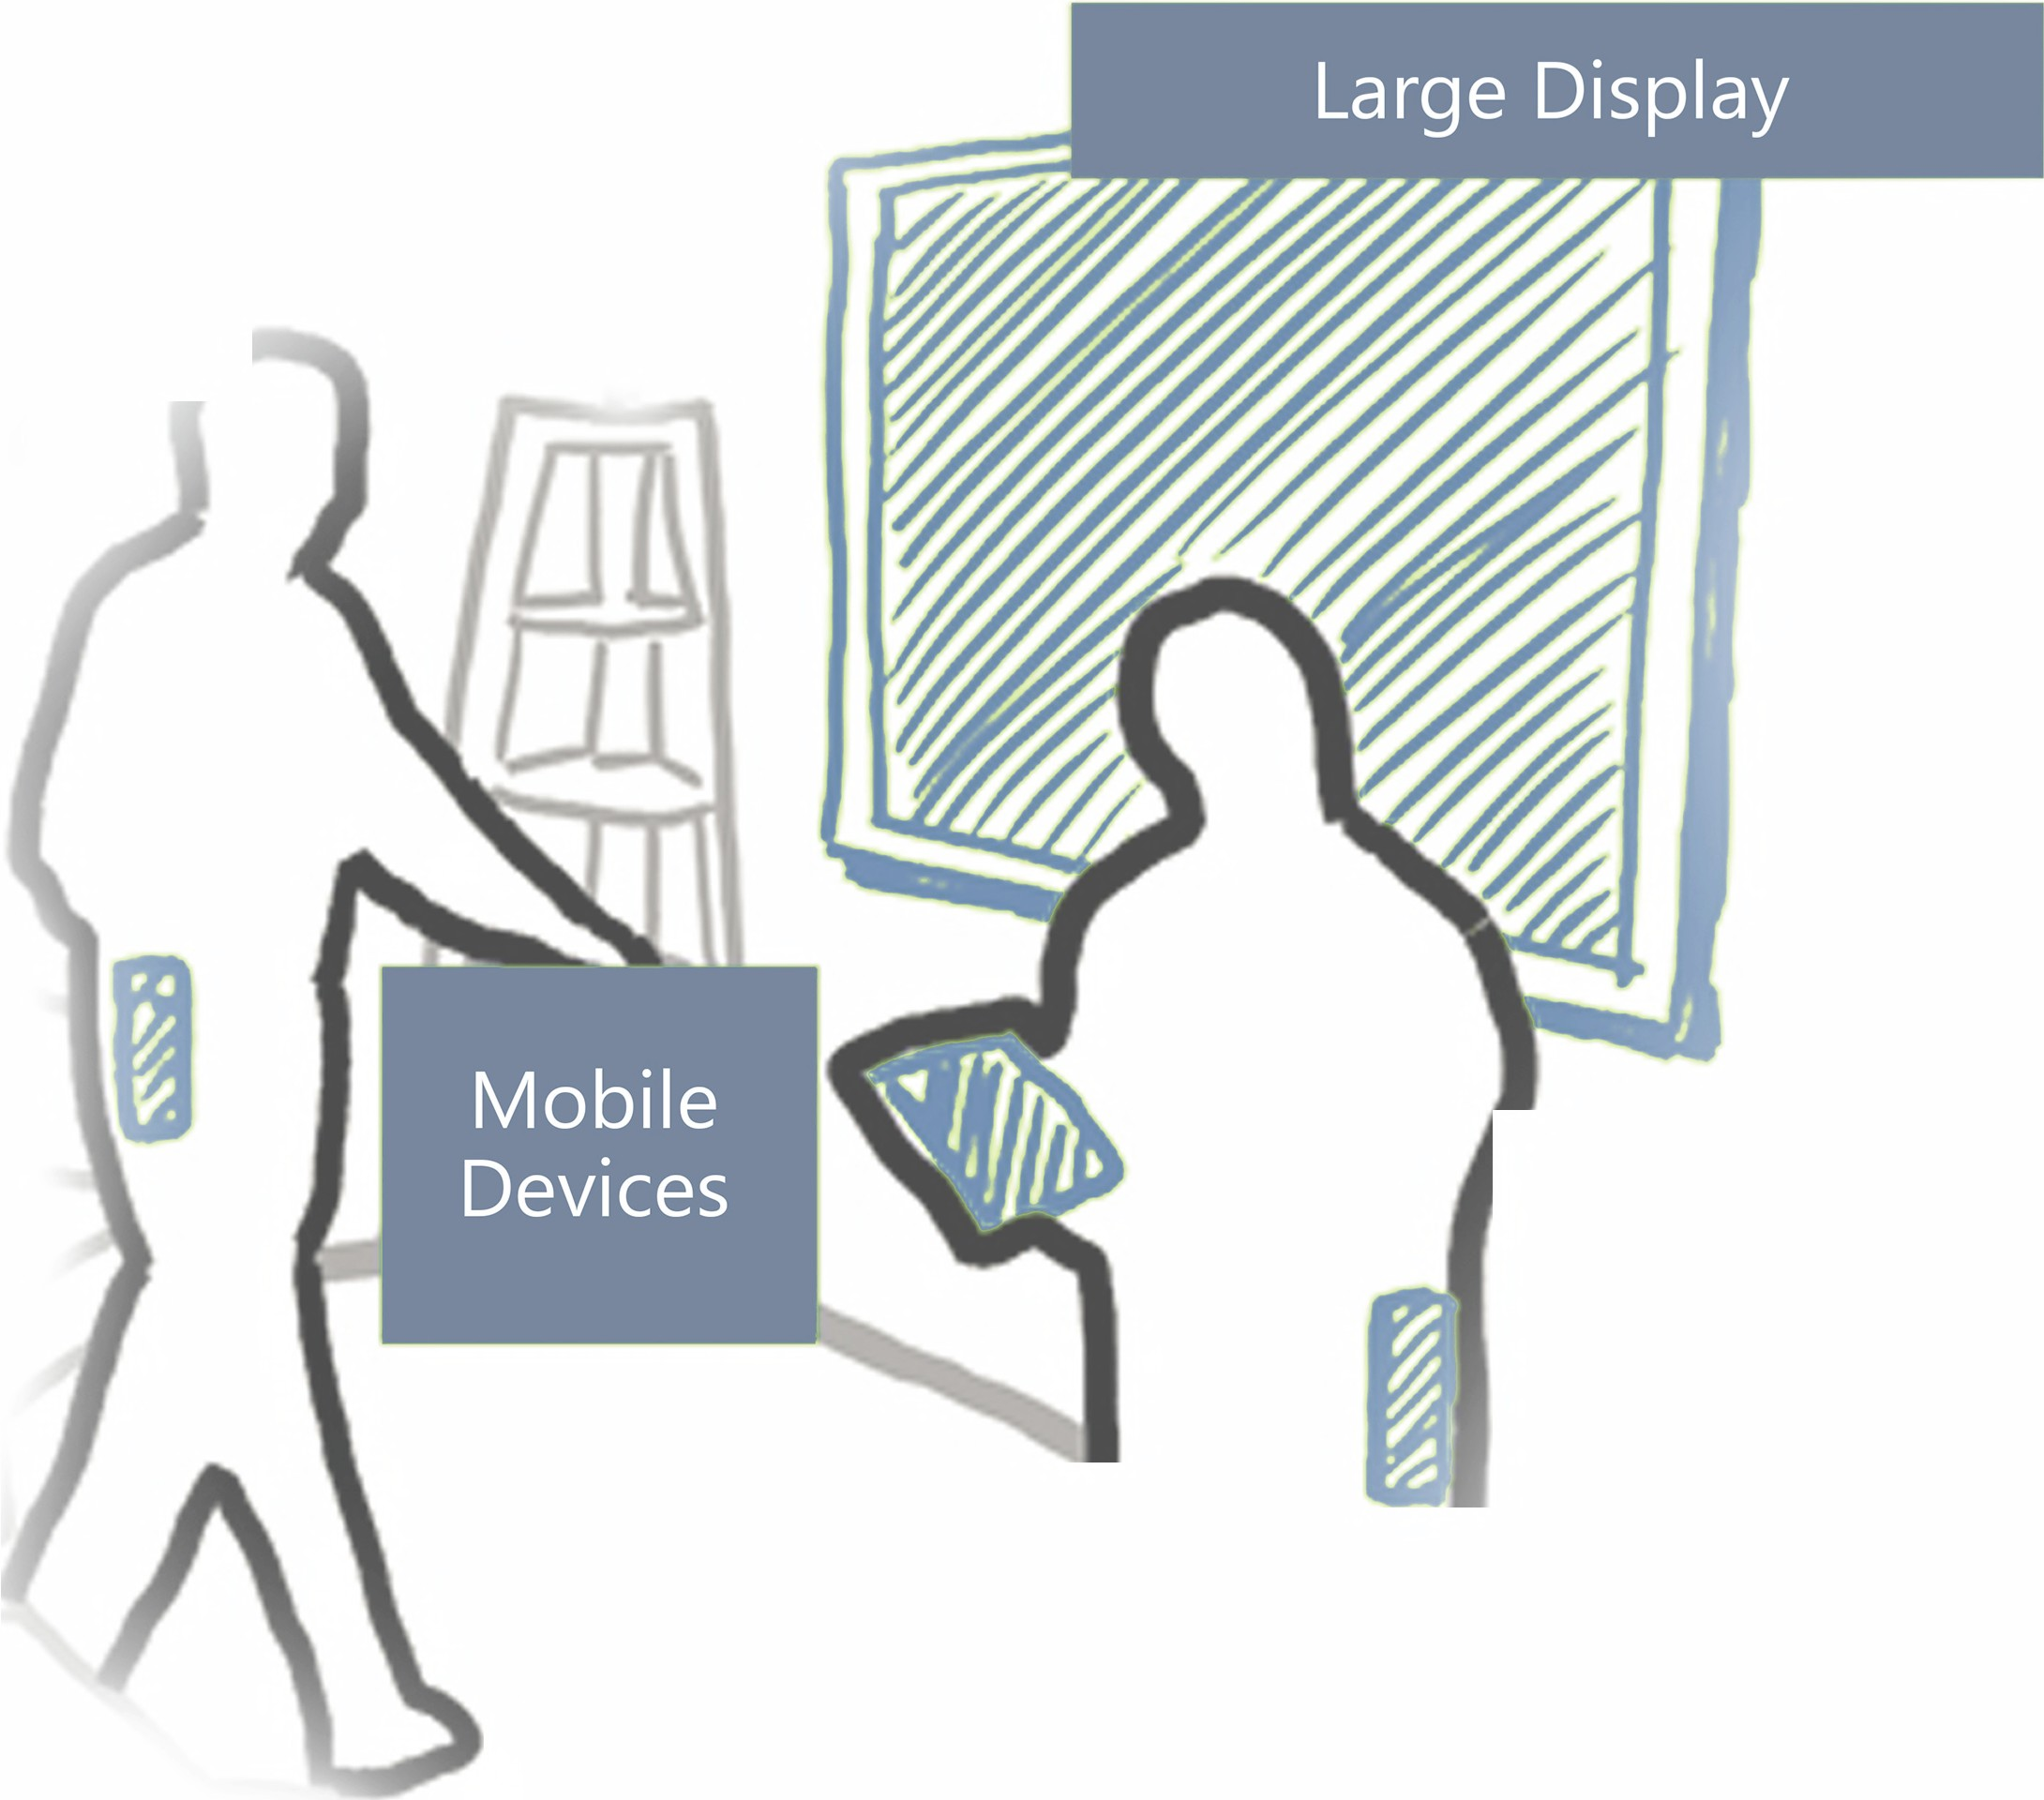

Aalborg University



Department of Computer Science

Group is903e15 • Autumn 2015

Bjarke M. Lauridsen Ivan S. Penchev

Elias Ringhauge Eric V. Ruder



Title of Literature Review:

Toward Cross-device Natural User Interac- tions with Large

Title of Research Paper:

Comparison of Push Techniques for Cross- Device Interaction Between Mobile De- vices and Large Displays

Project period:

IS9, Autumn Semester 2015

1st September 2015 to 18th January 2016

Group:

IS903E15

Participants:

Bjarke M. Lauridsen Ivan S. Penchev Elias Ringhauge

Eric V. Ruder

Supervisor:

Jeni Paay

Circulation: 2

Number of pages: 69

Appendices: 8 + 1 CD

Aalborg University,

Department of Computer Science

Selma Lagerlöfsvej 300

Phone 99 40 72 28

<http://www.cs.aau.dk>

Abstract:

Literature Review: In this paper we present a state of the art discussing the literature from two emerging and relatively new areas of the HCI field, namely cross-device interaction and natural user interaction. Papers from these two areas are reviewed and categorized into 5 themes: Interacting with large displays, Interacting with public displays, Natural user interactions, Cross- device interactions, and Public space and cross-device natural user interactions. We present an overview of each theme and analytically outline them, furthermore we discuss their connection presenting their overlapping areas. Our finding indicate a concentration of research in natural user interaction, and cross-device interaction, but limited work in cross-device natural user interaction, suggesting a gap in HCI knowledge worth investigating.

Research Paper: In recent years, research into cross-device interaction techniques has increased. Much of this research fo- cuses on interaction between mobile de- vices and large displays. We contribute to this body of knowledge with an empiri- cal comparison of four different push tech- niques - Pinch, Swipe, Throw, and Tilt for interaction between mobile devices and large displays. We report on Efficiency, Suc- cess rate and Accuracy. We also present the ease of use of techniques as perceived by users. We show that Swipe was the most effective in terms of success rate, effi- ciency and accuracy. Furthermore it gath- ered the highest score, in regards to ease of use, by users. Participants also reported that Pinch was the most fun to use.

TABLE OF CONTENTS

PR EFAC E ............................................................................................................... 7

INT R O DU CT IO N ....................................................................................................... 9

PAP ER 1: LI TE RATU RE REV IE W ..................................................................................... 11

PAP ER 2: RES EA RC H PAP ER ....................................................................................... 25

CO NC LUD IN G RE MA RK S ........................................................................................... 41

APP EN DI CE S

Appendix A: Questionnaire ............................................................................................ III Appendix B: Demographic Questionnaire ................................................................... V Appendix C: Questionnaire Results ............................................................................... VII Appendix D: Demographic Questionnaire Results ...................................................... XIII Appendix E: Example of raw comment log ................................................................. XV Appendix F: Example of raw test log.............................................................................XVII Appendix G: Recruitment Poster ................................................................................... XXI Appendix H: Pictures .......................................................................................................XXIII

2016

AALBORG UNIVERSITY

Preface

This collection of papers is the result of our 9th semester work, as software engineers, in Human Computer Interaction, at the Department of Computer Science at Aalborg University.

The theme of our project is cross-device interaction between mobile devices and large displays. Here we present two papers. First a literature review, then a research paper.

A CD containing the source code of the developed systems is supplied together with this report. The CD also contains a digital copy of this report as well as appendices with e.g. interview transcriptions. Additionally, it contains all logged numbers used for the quantitative analysis, enclosed as database exports.

We would like to thank Jeni Paay, Associate Professor at Aalborg University, for providing ongoing feedback and guidance throughout the project

Introduction

Our motivation for this semester’s project began with us being interested in Natural User Interfaces(NUI) in public spaces, with regards to the interaction between the users and the system, as well as with each other. For example, a project that sparked our interest was one that was being conducted at Aalborg University. They were creating a large touch wall where multiple users could come up and create music together by touching the wall in different places.

This lead us to our initial project idea: a collaborative NUI painting application using tangible objects as painting tools. This idea was too broad though and was based too heavily on a field we did not have that much expertise in; namely creative arts.

We then decided to focus on interaction between people and large public displays. This lead us to our current project theme: researching cross-device interaction between mobile phones and large displays.

Since this is a relatively new research field, this gives us the opportunity to provide foun- dational research for use with large shared public displays in applications such as bul- letin boards and interactive advertising boards.

The first paper is a literature review over the current state of the art in regards cross- device natural user interaction for mobile devices and large displays. In this work we analytically summarized relevant research outlining the current field and potentially identifying knowledge gaps. We look at works related to large displays, public displays, cross-device interactions, natural user interactions and the implication of public spaces on user interaction. We then use the findings to solidify our understanding of this knowl- edge area and set the foundation for our research paper.

The second paper presents a research experiment regarding four different cross-device natural user interaction techniques. These four techniques were being used in research papers and their prototype applications. Here we explore these techniques based on their success rate, efficiency, accuracy and ease of use. We do this by creating an experiment in which users have to hit several targets with each technique. We then present our result and discuss their implications.

PAPER 1: LITERATURE

REVIEW

TOWA RD CROSS-DEVICE NATURA L USER IN TERACTIONS WITH LA RGE DISPLAYS

AB S T R AC T

IN T H I S PA P E R W E P R E S E N T A S TAT E O F T H E A R T D I S C U S S I N G T H E L I T E R AT U R E F R O M T WO E M E R G I N G A N D R E L AT I V E LY N E W A R E A S O F T H E HCI FI E L D, N A M E LY C R O S S -D E V I C E I N T E R AC T I O N A N D N AT U - R A L U S E R I N T E R AC T I O N . PA P E R S F R O M T H E S E T WO A R E A S A R E R E V I E W E D A N D CAT E G O R I Z E D I N TO 5

T H E M E S : IN T E R AC T I N G W I T H L A R G E D I S P L AY S , IN T E R AC T I N G W I T H P U B L I C D I S P L AY S , NAT U R A L U S E R I N - T E R AC T I O N S , CR O S S -D E V I C E I N T E R AC T I O N S , A N D PU B L I C S PAC E A N D C R O S S -D E V I C E N AT U R A L U S E R I N T E R AC T I O N S . WE P R E S E N T A N OV E RV I E W O F E AC H T H E M E A N D A N A LY T I CA L LY O U T L I N E T H E M , F U R - T H E R M O R E W E D I S C U S S T H E I R C O N N E C T I O N P R E S E N T I N G T H E I R OV E R L A P P I N G A R E A S . OU R FI N D I N G I N D I CAT E A C O N C E N T R AT I O N O F R E S E A R C H I N N AT U R A L U S E R I N T E R AC T I O N , A N D C R O S S -D E V I C E I N - T E R AC T I O N , B U T L I M I T E D WO R K I N C R O S S -D E V I C E N AT U R A L U S E R I N T E R AC T I O N , S U G G E S T I N G A G A P I N HCI K N OW L E D G E WO R T H I N V E S T I G AT I N G.

2016

AALBORG UNIVERSITY

**Toward Cross-device Natural User Interactions with Large**

**Displays**

Bjarke M. Lauridsen Aalborg University [blauri10@student.aau.dk](mailto:blauri10@student.aau.dk)

Ivan S. Penchev Aalborg University [ipench14@student.aau.dk](mailto:ipench14@student.aau.dk)

Elias Ringhauge Aalborg University [eringh10@student.aau.dk](mailto:eringh10@student.aau.dk)

Eric V. Ruder Aalborg University [eruder10@student.aau.dk](mailto:eruder10@student.aau.dk)

**ABSTRACT**

In this paper we present a state of the art discussing the lit- erature from two emerging and relatively new areas of the HCI field, namely cross-device interaction and natural user interaction. Papers from these two areas are reviewed and categorized into 5 themes: Interacting with large displays, In- teracting with public displays, Natural user interactions, Cross- device interactions, and Public space and cross-device natural user interactions. We present an overview of each theme and analytically outline them, furthermore we discuss their connec- tion presenting their overlapping areas. Our finding indicate a concentration of research in natural user interaction, and cross- device interaction, but limited work in cross-device natural user interaction, suggesting a gap in HCI knowledge worth investigating.

**ACM Classification Keywords**

H.5.m. Information Interfaces and Presentation (e.g. HCI): Miscellaneous; See [http://acm.org/about/class/1998/ for the full list of ACM classifiers. This section is required.](http://acm.org/about/class/1998/)

**Author Keywords**

Authors’ choice; of terms; separated; by semicolons; include commas, within terms only; required.

**INTRODUCTION**

Weiser[38] points out:

“Ubiquitous computing names the third wave in computing, just now beginning. First were mainframes, each shared by lots of people. Now we are in the personal computing era, person and machine staring uneasily at each other across the desktop. Next comes ubiquitous computing, or the age of calm technology, when technology recedes into the background of our lives.”.

Paste the appropriate copyright statement here. ACM now supports three different copyright statements:

• ACM copyright: ACM holds the copyright on the work. This is the historical ap- proach.

• License: The author(s) retain copyright, but ACM receives an exclusive publication license.

• Open Access: The author(s) wish to pay for the work to be open access. The addi- tional fee must be paid to ACM.

This text field is large enough to hold the appropriate release statement assuming it is single spaced.

Every submission will be assigned their own unique DOI string to be included here.

Weiser’s vision of ubiquitous computing, is over 20 years old, includes the ubiquity availability of computers that are preferably not distinguishable from everyday objects. He also talks about "calm technology", which is this technology that resides in the periphery and plays a non-dominant role in a user’s life. The perception of devices plays a major role in Weiser’s vision, however the other side of that is availability of devices and also computing power, which is important for cross-device interaction. As so we could contend and regard that the latest incarnation of Weiser’s vision is cross-device interaction, where ideally joining several devices would lead to single seamless, and natural user interaction, flexible, and not restricted to a few configurations[26]. In order for this interaction to happen we need to remain as close as possible to the real world and have multimodality in mind, as Jain et al. states: “human interaction with the world is multi-modal, and rich multi-modal interaction is part of what defines a natural experience.”[16]. This corresponds well witth the way Wigdor and Wixon defines NUI , where "Natural" is about how the users feel and what they do when using a product. The prod- ucts must mirror the user’s capabilities and meet their needs, but the trick is to help the users feel comfortable about the product without the need for much practice[40]. This becomes important for the design of product that has a non-dominant role in a user’s life as the user should not be using a lot of time for adapting to the products. Ideally we would see a combina- tion of multiple modalities, for instance gestures, augmented reality, touch, voice recognition etc. Researchers have made and published breakthroughs and designers constructed inno- vation design in each modality individually, however there has only been little research and work in combining them [16].

It is possible for the existence of untapped opportunities in the integration of multiple natural user interaction modalities for enriching the cross-device experience with hand-held devices and large public displays.

In this paper we review the research that has been done within interaction with large displays. This has been done to map the current understanding and practices, thereby helping future researchers, within this field, to gain a perspective as well as identifying possible untapped opportunities for future work.

**STATE OF THE ART OF INTERACTING WITH LARGE DIS- PLAYS**

We present an overview of research in interaction techniques

for cross-device interaction between hand-held devices and large display, with an emphasis on natural user interaction.

Our initial literature search was based on an interest for devel- oping walk-up and use large display technologies for public spaces.We looked at MobileHCI, CHI and ITS conferences in the last 5 years, based on the recent research, presented in those conferences, we selected areas that we thought inter-

Theme Paper

Interacting with large displays [38] [13] [39] [5] [9] Interacting with public displays [29] [25] [31] [2] [15]

[28] [21] [35] [14]

Natural user interactions [16][19] [36] [1] [18] [37] [40] [41] [7] [10]

Cross-device interactions [20][30] [27] [12] [26] [32] [3] [34]

sect between research needs and our interests. Those selected

Public space as a challenge for cross-

[6] [29] [8] [11] [22]

were: Cross-device Interaction, Large Displays, Multi-device Interaction, Natural User Interface, Proxemics, Public Space, Social Interaction, Tabletop Interaction, and Tangible Inter- action. We used these topics for further inquiry publications within those areas. For the purpose of that we used ACM DigitalLibrary, SpringerLink and Microsoft Research. From this search and the set of papers found during brainstorming, we kept a total of 56 papers.

Based on one of our ideas and the literature we had found, a choice was made to conduct research on interaction techniques for cross-device-interaction between hand held devices and large displays and hereby to even further investigate the re- search done within the areas of Cross-device Interaction, Large Displays, Multi-device Interaction, Natural User Interaction, Proxemics and Public Space, however this meant foregoing Public Space, Social Interaction, Tabletop Interaction, and Tangible Interaction as part of our continued research. We chose to narrow the search down even more by focusing on interaction techniques, cross-device interaction, large displays, and technology that could be used to carry out our idea. We added a strict criteria, that the paper should contain one or more interaction techniques. This resulted in an additional 21 papers.

With a total of 77 papers, we reviewed, by writing a three bullet-point list containing the research ideas in each paper, their scientific investigation, this help us to finalize our own research idea. We settled on which interaction techniques are most effective, in terms of hit success, efficiency, accuracy and ease of use, for cross-device natural user interaction between hand-held device and large display in public space? After finalizing our research idea we choose to do a secondary sort, based on our final research question, this resulted to removing papers that were unrelated to the research idea and its appli- cation. The final set contained 34 literature sources which we further examined, by writing a short summary for each paper which included " title, author’s thesis (aim of paper), objectives (goals, summaries), methodologies used, findings, conclusion, and keywords ". Using applied thematic analy- sis different themes were induced on the summaries, which we later categorized into 5 themes: interaction with large displays, interaction with public displays, natural user inter- actions, cross-device interactions, cross-device natural user interactions.

The identified themes and the specific papers correlated to them are presented in Table 1, with full citations in the refer- ences section of this paper.

device natural user interactions [23] [33] [4]

Table 1. Themes of the reviewed papers.

**Interacting with Large Displays**

Weiser states that ubiquitous computers have to be of different sizes, each suited to a particular task. Weiser and his col- leagues have build small and large displays and encourage the reader to consider the amount of surrounding items that displays information, such as labels, bookspines, thermostats, etc. He states that the items “leads to our goals for initially deploying the hardware of embodied virtuality” [38].

Early use of tabletop display is showed by Wellner in the form of Digital Desk, he utilized optical and acoustic finger detection on the tabletop, and also played with the possibility of tactile manipulation of physical objects on the surface.[39] Portfolio Wall was developed at the end of the 90s as a system that utilized a vertical touch-screen display by Buxton[5]. His idea was proposed as a corkboard in digital format used to share work inside the design team.

Large displays can have positive effect on productivity argues Czerwinski et al. [9] They made a study on the productivity of using large displays in a office. They hypothesize that there will be a cognitive load advantage and a reduction in window management by using a large display. They build a novel

42” wide surface called DSharp by combining 3 projectors onto a curved Plexiglas panel that gives an almost seamless display with a 3072 x 768 resolution. In a user study they compare a 15” flat panel display with their DSharp display to deduce if there was a significant performance advantage by performing tasks on the larger display. Their results showed a significant faster task completion time on the larger display corresponding to a 9% increased productivity and that 14 of their 15 participants preferred the large display.

However Czerwinski et al. [9] also discovered some usability issues for the large display during their test, such as the dis- tance between the display and user being too small as some users would prefer to back up and interact with the display at a distance. They also discovered that the software design didn’t fit the usage of multiple displays, as the users mentioned that the amount of navigation and losing the cursor on the display were the most onerous problems with the large display. Czer- winski et al. suggests that the taskbar is stretched across all the displays, and that the start menu and notifications comes up on the display which the user has its attention on. Likewise

they suggest to improve the visualization of the cursor to make it easier to locate on a large display [9].

Rapid progression in the technology for displays and projec- tions, naturally led to lowering of the marginal price, thus “large displays have moved out of research laboratories into public spaces such as museums, libraries, plazas, and archi- tectural facades, where they present information and enhance experiences” [13]. While we know from Czerwinski et al.’s [9] findings that large displays provide an increased produc- tivity, we also know that there are usability challenges such as tracking the cursor and lack of design that supports mul- timonitor displays. Futhermore Czerwinski et al.’s findings also suggest that users wants to interact with large displays from a distance, which both brings new challenges as well as oppotunities. We have examined the large display in an office and lab context that doesn’t take the complications of public space into consideration; this will be done in the next section.

**Interacting with Public Displays**

Rapid progression in the technology for displays and projec- tions, led to considerable proliferation of large displays, thanks also to their capacity to promote activity and social awareness [14], they moved out from research laboratories into public spaces. However, according to Brignull and Rogers: “these displays typically present predetermined feeds offering no in- teractivity” [29]. Ten years later Ojala et. al still support this thesis, that “to date, however, these displays are still used primarily as one-way commercial digital signs.” [25]. Nevertheless researchers continue to combat and change this trend, as such a body of research has formed around interac- tive public displays. A large part of this body presents unique solutions for installations and devices for particular public settings with specific display technology [31].

Boring and Baur address the problem of crafting interaction techniques that can be used in an array of settings while at the same time maintain some autonomy from the components of public space and different display technology. They have done so by developing a “[...] conceptual framework and technical implementation that rely solely on the public displays and users’ mobile devices.” [2]. By leveraging cell phone cameras they have enabled from-a-distance interaction with any public- display technology.

The framework allows for calculating the phone’s distance and orientation to the display, if the display’s physical size is known. This is done by locating features on the image from the public display and matching them with the image seen on the phone. The comparison is used to calculate a transformation matrix that maps the x and y coordinates from the phone to the corresponding x and y values on the display. Because the analysis is done on the image itself it is sufficient to have a subregion of the display image shown on the phone.

To support animated content, the display saves the screen- shots in a queue with timestamps. The server that performs the calculation will synchronize its clock with the connected phone, so it can compare the timestamp from the phone with the queue and select the appropriate screenshot for feature point comparison.

By connecting several displays to a server it is possible to support interaction between a user and several displays at the same time. However the amount of comparisons the server has to make also increases for each display that is added and thus decreases the detection speed and eventually harms the real-time interaction. The set of displays that an image has to be compared against can be reduced by using GPS (location), compass (direction) and accelerometer (orientation) data from the user’s phone, to discard displays that isn’t being pointed at.

From-a-distance interaction using handheld devices is not the only way to interact with public displays. Jacucci et al. adopted touch as a base for their “Worlds of Information” system. Their touch solution was groundbreaking due to sup- porting multiple touch and users at the same time. Multi-touch can create a playful environment that engages users, fosters social learning, social experience and creates an attractive honey pot effect. However, Jacucci et al. states that: “the challenge is to move beyond ephemeral interactions, driven by the playfulness of the interface, and to encourage users to pay attention to the content also exploring more complex functionality”[15]. They “discuss how to design for and evalu- ate engagement in a public walk-up-and-use installation” and state that a ““walk-up-and-use” system needs to be so self- explanatory that first-time or one-time users need no prior introduction or training”[15]. From their survey data they found that overall users responded positively to the system, but different groups of users either found it less interesting or felt less competent, indicating that supporting different levels of competence did not work perfectly. They conclude that the Walk-up-and-use display can greatly benefit from multiple touch support, but it was not all users who fully exploited this feature.

Gang Ren and his team explain how they used input based on gestures to navigate 3D imagery and how such interaction techniques influence social dynamics around the display. They point out that “for large public displays, gestural interaction can enhance the experience of not only the current user but also the people sharing that public space or activity.” [28].

This observation led to value which could be exploited, as Lucero et. al. tried to do. Focusing on the collaborative and cross-device side, Lucero et. al. created MobiComics with the purpose to “explore shared collocated interaction with mobile phones and public displays in indoor public place.” [21]. They discovered that most of their participants (36) were positive about using their personal devices to create a common interaction space, but some of them would only share their devices with people they knew. Additionally they found that half of their participants raised concerns for privacy in regards to taking pictures of strangers in the public space and 10 were also concerned about people being able to keep MobiComics after the session.

Valkanova et. al tried to focus on the discussion and natu- ral user interaction side by creating MyPossition, a “public display in the form of a large projection, featuring an interac- tive poll visualisation.” [35] which aimed to aggregate public opinions for local issues by utilizing voting with gestures.

By allowing passersby to vote on civic topics the system is an example that succeeded in getting people to interact with the content rather than merely playfully exploring the inter- active features. This was achieved by presenting people with personal traits of previous participants that we in the form of silhouettes or photographs, which led to observed consid- erable discussion and nudging among people, in particular beyond the interaction area in front of the screen, accountabil- ity of their vote positively impacted the overall enticement of onlookers to engage with the system and the ongoing topic.

In this section we explored literature on interacting with public displays. Firstly we see a difference between large display and public display that almost every paper about public display includes the context of getting the users attention. This is often done by creating content that attracts people and tries to achieve a honeypot effect. another challenge is the need to create immersion and focus on the content, as well as working with the challenge of playfullness - to make the user do more than just play with the system. Finally we can see two clusters of research papers emerged, one on natural user interaction, and another on cross-device interaction.

**Natural User interaction**

Natural user interactions are underlaying for the natural user interface. The "natural" in Natural User Interface is about how users feel and what they do when using a product. A product should take full advantage of the user’s capabilities; the trick lies in making the user feel that it is natural from the start and not after a long time practicing. That does not mean that the product should be designed towards no learning requirements; it can be a better solution to make the user learn how to deal with the technology than making the technology deal with the complexity of humans. An example would be Apple’s New- ton Message Pad which was promised to understand human handwriting. The results were bad as the handwriting recogni- tion was insufficiently robust. The successor Palm Pilot(1997) by Palm computing had more success, as the creators rec- ognized the limitations of their technology. They developed an input language similar to roman characters that the users had to learn, however the experience felt natural because the recognizer worked so well [40].

In 2001 Keefe et al. [19] created a 3D virtual reality painting system where they used tangible items like a brush and cups for selecting brush type, to create an intuitive interface for artists who might not be familiar with virtual reality. The brush is tracked in the 3D space and the color palette is opened by making a circular gesture while holding the brush in an upward position; a color selection is made by moving the brush to a color and tilting the brush into another direction. For advanced users a tracked glove can be used on the non-dominant hand to provide quick access to changing color and brush size. The tracking however requires special cabled equipment, which results in additional weight on the hands and reduces the free movement.

Microsoft released the Kinect for Xbox 360 in 2010[7] and the Kinect for Windows in 2012[10]. The Kinect has a depth sensor, color camera sensor, and four-element microphone array. We found that the Kinect has been a tool for much

research, many of them utilizing the depth sensor, which is the case of the following papers:[41, 1, 37].

Wilson [41] wanted to explore the application of depth-sensing cameras to detect touch on a tabletop. He found it to be less precise than touch screens, but with three advantages. The surface does not need to be instrumented; The surface is not required to be flat; and the information about the shape of the users and their arms can be exploited in useful ways, such as determining hover state or whether multiple touches is from the same user [41].

Motivated by surface and tabletop systems expansion to in- clude proximity sensing, Aigner et al.[1] looks at the Point- and-Click interface and User-Defined Interface(UDI). They find that Vogel and Balakrishnan [36] built a Point-and-Click interface for large screen displays which simulates mouse input, and that several issues was discovered: precision in pointing, ambiguity of finger movements, and lack of physical feedback. They describe that it has been common to elicit ges- tures by applying the UDI methodology, but researchers have found that there is little consensus among users in association between gestures and their expected effect.

Aigner et al.[1] believe that gesture languages have to be de- signed rather than observed, however a key limitation is the lack of guidelines for designing such languages. They de- veloped a Gesture type classification scheme based on the taxonomy of Karam and Schraefel [18] . From their experi- ment they found that the participants used a wide variety of gestures to accomplish the same effect, but the type of gesture was often consistent across time and participant. Hence, their results suggest that "classifying by type reveals a much greater degree of consistency" compared to eliciting gestures by using the UDI methodology.

Walter et al.[37] state that today’s public displays only show predefined contents that passers-by are not able to change and argue that displays would benefit from techniques for in- teracting with large displays. They propose a design space for hand-gesture based mid-air selection techniques based on analysis of differences and similarities of existing mid-air se- lection techniques in NUI frameworks, commercial products and related work. From two lab studies they derived 4 selec- tion techniques that supports immediate usability. In a field study they found that the 4 techniques performed equally and conclude that designers can choose freely between those 4 techniques. They give their recommendation for designing of interactive public displays, that allows users to select options using mid-air gestures; and believe that their findings will make the platform of interactive public display more attractive to users.

In this section we have explored literature on NUI, showing some of the early development and some of the later devel- opment where the Kinect has been used. From this we can deduce that there have been a focus on exploring the applica- tion of depth-sensing cameras as well as understanding and designing mid-air hand gestures. Using the Kinect as a tool we can achieve interaction in a limited 3D space without the need for additional tools, such as tracked controllers or gloves.

The Kinect can be used to achieve touch detection on non- instrumented surfaces or in midair by using the depth sensor to detect distance and recognize gestures. Aigner et al.’s and Walter et al.’s results have been recommendations and guide- lines for selecting and designing hand gestures for interacting with the Kinect. Aigner et al.[1] believes that a gesture lan- guage has to be designed instead of observed. Through the observation of participants communicating by using gestures in a lab study, they discover that the participants often used the same type of gesture to achieve a desired effect. Walter et al. argues that public displays would benefit from techniques for interacting with large displays. They made a designspace which they tested to derive the selection techniques that sup- ports immediate usability. In a field study they found that their 4 derived selection techniques performed equally and concludes that designers can choose freely among them. With these findings we are now aware of several applications where the Kinect can be used for interaction and which types of inter- action techniques that provides the user with a good experience when using the Kinect.

**Cross-Device Interaction**

Interaction was understood, usually, as single user using a single device, this was almost always a desktop computer[20]. We have moved from this protocol into the more complex world of cross-device interaction, as such it is important to give definition of this phenomenon.

"Cross-device interaction is the type of interaction, where human users interact with multiple separate input and output devices, where input devices will be used to manipulate content on output devices within a perceived interaction space with immediate and explicit feedback." [30].

Rikimoto presents an early envisionment of this idea. In his work the technique he proposed was a Prick-and-Drop tech- nique, he explains that "Pick-and-Drop allows a user to pick up an object on a display and drop it on another display as if he/she were manipulating a physical object." [27]. The author discusses how, even though from a functional point of view, the technique does not differ from a traditional remote copy command, the added extra layer of physicalness makes a dif- ference for the user. "understanding that we are living in a fusion of physical (real) and virtual (computer) worlds. Each has its own advantages and disadvantages. Pick-and-Drop, for example, adds physicalness to user interfaces, because we feel that traditional data transfer methods are too virtual and hard to learn due to their lack of physical aspects" [27] remarks the writer.

Perhaps one of the earliest working systems illustrating CDI is by Myers et al. [24] one of the application realized within their Pebbles project is SlideShow Commanded that utilized Personal Devices Assistants (PDA) to control a PowerPoint presentation running on other computer or laptop. It was possible not just moving between slides, but also scribbling and writing on the PDA slides, while annotations are shown on the presentation for the audience.

A more modern reading on this comes from Hamilton and

Wigdor, they wanted to see how the users would utilize a group

of tablets with cross-device capabilities. For this task they crafted "Conductor, a prototype system that combines a set of interaction techniques designed to enable single user, cross- device applications, manage cross-device relationships, and enable easy functionality chaining." [12] to achieve this task they uses traditional menus with color-coded device names to select the tablets to share information with or to chain tasks across them. However the experiment and the user study done affirmed that keeping track of multiple, often very similar devices can represent a surprisingly significant challenge, and also that users extensively used spatial configurations of tablets for categorical organization. In other words, although menus are a familiar and expected way to select items which have no clear spatial relation, they might seem burdensome for the purpose of selecting one out of many devices from a spatial configuration.

This spatial aspect makes Radle et. al continued with the multi- tablet cross-device interaction, and ask what is the appropriate design of this cross-device interaction. In other words their focus shift to the competing interaction approaches such as spatially-aware vs. spatially-agnostic techniques. In order to do that they firstly define three main categories of cross-device interactions:

1. Synchronous gestures

2. Spatially-agnostic interactions

3. Spatially-aware interactions.

After which they perform a two-phase user study that explores the design space. Based on the experiments they found that "the results indicate that spatially-aware techniques are pre- ferred by users and can decrease mental demand, effort, and frustration, but only when they are designed with great care." [26].

Cross interaction between the same type of device are not the only one. Schmidt et al. propose a cross-device interaction style for mobiles and surfaces. The researchers point out that "natural forms of interaction have evolved for personal devices that we carry with us (mobiles) as well as for shared interactive displays around us (surfaces) but interaction across the two remains cumbersome in practice" [32]; so in order to overcome this they propose to use mobiles as tangible input on the surface in a stylus like fashion. While Schmidt et al. focuses on close interactions Boring et. al. tackles the in- distance aspect. More specifically they explored the transfer of data from a large public display onto a mobile device by using the camera on said device. They show that there is a need for enabling data exchange between mobile devices and public displays. Their idea is to combine the large-scale visual output and the mobile phone as an input, to enable a channel of communication, which is bidirectional, with the large public display. To do this they "propose and compare three different interaction techniques (Scroll, Tilt and Move) for continuous control of a pointer located on a remote display using a mobile phone" [3].

Skov et al. [34] illustrate six different cross-device interaction techniques for the case of card playing in Investigating Cross-

Device Interaction techniques. A player can see their own cards on their phone and use three different techniques for playing a card from the handheld to the tablet, which is placed on a table. In the other direction, i.e. when drawing a card, the player also has three techniques to choose from. The usability study aims to quantitatively evaluate each of the techniques and showed that there is a difference in time and number of errors between the techniques. The findings that the authors present show that coping the natural gesture of card playing in the form of wrist-whip interaction technique, resulted in a slower than the other techniques, which the users reported as less useful and natural. In regards to interaction errors the swipe interaction technique causes significant problems which results in participants making more errors. The field study presented by the authors shows that when playing in real card game situations, people mix up the techniques and thus perform a wrong action.

The current paragraph exemplifies that designing a solution for cross-device interaction can be complex, as such to understand unique properties and challenges of the domain is a must. The early literature focuses on interaction support. Gradually this evolves to understanding the interaction process itself in different device environment i.e. large display and hand- held device, and multiple hand-held device.With the body of knowledge on cross-device, and natural interactions as part of large display, a logical step is to look and ask if researchers have tried to combine CDI and NUI in public spaces with large displays.

**Public space and cross-device natural user interaction** Different field of studies have long held the view that the phys- ical and social dynamics of public space play a central role in the formation of publics and public culture. Car et al, argued "when public spaces are successful [...] they will increase opportunities to participate in communal activity. This fellow- ship in the open nurtures the growth of public life, which is stunted by the social isolation." [6]. For Computer Science this view was embraced with the new opportunities presented by the technological possibility to include the public space inside the ecology of a computer system. As such research investigating how public space can affect interaction with the system and vice versa spanned.

In historical perspective Brignull and Rogers work[29] is the first that investigates interaction flow in the context of pub- lic space for large displays. They observe that even though large displays are increasingly placed in public places, to sup- port community and social activities, people are reluctant to use them. They point out that the main reason, for existing resistance by the public to participate, is the prominence of the affective aspect of the user experience - feelings of social embarrassment. In order to understand this phenomenon they create a conceptual framework for analyzing public interaction. Their framework consist of three different spaces (1) Space A peripheral awareness of displays - people are engage in unrelated activities (2) Space B focal awareness - - people are engage in associated activities (3) Space C direct interaction - people engage in interaction with the display. They point out " it appears that the key bottlenecks occurs in public interaction

when people have to make transitions between different activ- ity spaces ". They conclude it is crucial for public interaction to be able seamlessly and comfortably to transition between onlooker and participant and one way to do that is to encour- age people to cross the thresholds from peripheral awareness to focal awareness without becoming self-conscious.

While Brignull and Rogers work focuses on interaction with Large Displays, Cheung et al. extends that to interaction barri- ers for cross-device public displays [8]. They focus on interac- tion process comprised of personal devices (capturing unique traits such as privacy and novel interaction mechanisms), and a large display (which is used as a shared display, and a direct input alternative, if supported), and list in partial order the usage barriers, for engaging a passerby while clustering them in three groups: (1) Attract - how can we combat display blind- ness (notice the display), interaction blindness (be aware we can interact with the display), and cross-device blindness (be aware we can use personal devices as a mean of interaction); (2) Interact - how can we combat complex interaction (easily understand how to make use of large display and personal device), social inhibition (do not feel social embarrassment), and how can we opt-in/out (engage or withdraw from the sys- tem); (3) Manage - how can we maintain and communicate the connection between the large display and personal device (connecting, explicit disconnecting, implicit disconnecting), how can we recover from interrupting states (eg. Phonecall).

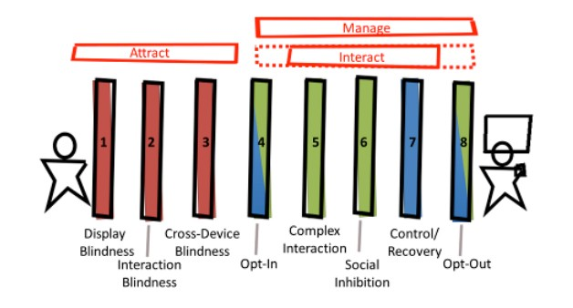

(a)

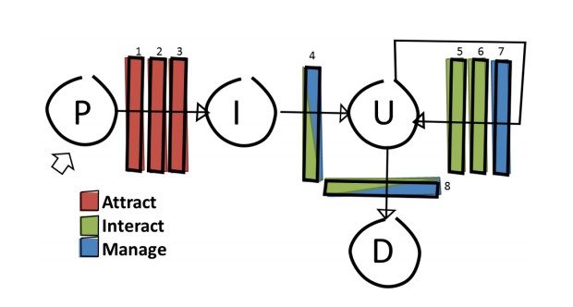

(b)

Figure 1. Adopted from Cheung et al. [8]. (a) cross-device interac- tion barriers for interacting with large displays and hand-held device (b) States of interaction and barriers encountered.(P:Passing, I:Interested, U:Using, D:Done).

After identifying the barriers to cross - device interaction Fig- ure 1a they model the interaction process as a series of states Figure 1b stating that ideally a passerby will proceed through

each state and engage the system. They conclude that each barrier in their design framework must be addressed in order for the users to be enticed to interact with the system. To sum- marize there is a need to take physical and social dynamics into consideration when designing for public space as people are reluctant to use public installations. Car et al. argues that opportunities to participate in communal activity are increased when public spaces are successful, which in turn nurtures the growth of public life [6]. Brignull, Rogers [29], and Cheung et al. [8] all agrees that people avoid the installations due to social inhibition. Brignull and Rogers creates a conceptual framework for analyzing public interaction and trying to under- stand why people feel social embarrassment. They argue that the key bottleneck in public interaction occurs when people have to transits between activity spaces and concludes that it is necessary that people can comfortably and seamlessly transit between being an onlooker and a participant. They suggest to encourage the people to make the transition while avoiding that they become self-conscious about it. .

Cheung et al. tries to identify and list the usage barriers for engaging a passerby into interaction between a public display and their personal device. They identify 3 groups of barriers: (1) Attraction - how can we make people notice the display and realize that they can interact with it? (2) Interact - How can we make a system that is easy for the people to understand and use without feeling socially embarrassed? And (3) Manage - How can we maintain and avoid interruptions in communication between the public display and the peoples personal device. They make a model that describe the barriers and conclude that those barriers must be addressed for making people interested in interacting with the system.

While there are challenges to overcome in the public space, we also saw research that suggested improvement of the usability of the system. When it comes to interacting with public dis- plays, Walter et al. [37] points out that many public displays today only show content that cannot be interacted with. They suggest that public displays would benefit from techniques for interacting with its content and make the platform of inter- active public display more attractive to users. They derived

4 techniques from lab studies and verified their usability in a field study, which they suggest for interacting with public displays. In the field of Cross-Device Interaction Rikimoto [27] suggest a pick-and-drop technique for data transfer be- tween devices. He argues that the technique does not does not differ from the traditional remote copy command, but that the added layer of physicalness makes a difference for the user. He states that we live in a fusion of the physical (real) and virtual (computer) world, and the reason to select a technique that adds physicalness to the user interface is because traditional data transfer are too virtual and hard to learn without physical aspects.

These findings carry the notion that there is a need to inves- tigate the fusion of cross-device interaction and natural user interaction fields in public space context.

Infusing the two fields could offer new concepts and potential ideas, as such an inquiry of the current literature would be beneficial. An illustrative example, on transitioning from one

to another area, would be Greenberg et al. work [11] who ex- pand on a concept from Psychology, which states that different distance between people can explain their relation, by adapting it for use in HCI, they do so by concerning distance, not only between people, but between all objects such as people, elec- tronic devices and analogue objects. Their main contribution is in defining five proxemic dimensions: Distance, Orienta- tion, Movement, Identity and Location. This dimensions can be used to help devices, in a system ecology , to recognize their current context, distance to other people or devices, and can help creating interconnectivity between entities.

Marquardt work, that proposes to use spatial information - proxemics “[...] to mediate people’s interactions with digital devices, such as large digital surfaces or portable personal de- vices.” [22], gives an illustration of the use within cross-device. He presents design of development tools for programmers cre- ating proxemic-aware systems, his aim is “to create techniques that allow people to seamlessly and naturally connect to and interact with the increasing number of digital devices.” [22].

Marquardt et. al.[23] later expand this idea by increasing the number of dimensions i.e. he augments proxemic principles with theories of F-formation and micro-mobility, his creation is a system that uses combination of Kinect sensors and ac- celerometer data, which was combined to determine the loca- tions and orientation of users in an instrumented environment . This information was used to facilitate a number of real-time interactions between user devices, as the author writes “[...]a system that explores cross-device interaction using two socio- logical constructs. First, F-formations concern the distance and relative body orientation among multiple users, which indicate when and how people position themselves as a group. Second, micro-mobility describes how people orient and tilt devices towards one another to promote fine-grained sharing during co-present collaboration.” [23]. Combining these two aspects, new techniques of cross-device interaction with em- phasis on fluid and smooth communication can be designed argues the author. For instance, tilting a device by a small angle may trigger an information sharing process with other devices within proximity.

Proxemics is one of the ways to create cross-device natural user interaction. Bragdon et al. propose using a system that combines touch + air gesture hybrid interactions. They aim to design, implement and test a system that allows a group of users to interact using air gestures and touch gestures. The purpose is to increase control, support democratic access, and share items across multiple personal devices such as smart- phones and laptops where the “primary design goal is fluid, democratic sharing of content on a common display.” [4]. This method enables access, control and sharing of information through several different devices such as multi-touch screen, mobile touch devices, and Microsoft Kinect sensors. In a for- mative study, professional developers were positive about the interaction design, and most felt that pointing with hands or devices and forming hand postures are socially acceptable. An open question about hybrid of touch and mid-air gestures inter- actions is how these ways compare and when user choose one over the other. Jakobsen et al [17] have toggled and answer for

this question, they performed two experiments In the first they compare touch and mid-air gestures to identify their relative performance for target acquisition. In the second experiment, participants were given the option to choose freely between touch and mid-air gestures, while the researches artificially required movement to simulate situations where mid-air will be considered beneficial. Results indicate mid-air to be overall slower than touch depending on the task in the first experiment; for the the second experiment, results show participants mostly chose touch in particular for selecting small targets and they rarely switched between mid-air and touch. An interesting observation is that when faced with an increasing cost of using touch in the form of movement, participants chose mid-air over touch.

**Discussion**

This paper aims to analytically summarize published research within the areas of interaction with large displays, natural user interaction, and cross-device interaction.In this section we expand on the relationships between presented different fields, we believe this will further deepen our understanding of them.

By making the objects that surround us change their non- interactive state to a responsive medium, Buxton[5] and Well- ner[39] achieved a novelty supporting Weiser’s vision of ubiq- uitous computing. A secondary objective of Weiser was related to the size of the object. An example of this principle can be related to the work of Czerwinski[9] that shows how size can correlate to the performance in a work environment.

A new state is often related to not only a technologically progress but also conceptual ideas. A Technological example would be the development of the Kinect that provide new interaction possibilities[41], and a conceptual example is to use tangible objects as a medium for interacting with the virtual world[27, 19]. This change provides new opportunities and challenges for developing interaction techniques in the interaction space of natural user interaction and cross-device interaction. These two identified areas differ in-between, however they also have common ground, we present this idea in Figure 2.

We reflect upon how the shift from private to public environ- ment correlates with the challenges in natural user interaction and cross-device interaction for interaction techniques. While there isn’t a specific formula covering the creation of an ideal interaction technique, there are some guidances. For example Brignull[29] advises to make the transition between an on- looker to participant less socially awkward. Cheung[8] shows that there are specific barriers for interacting and presents a diagram of each state when said challenges are encountered, he advises that those should be addressed in every case. How- ever we notice that the majority of papers we examined do not explicitly focus on the environment, instead they present unique solutions, without beforehand taking into considera- tion the settings. From the research done on public space and public display we are able to identify 3 elements that directly impacts the creation of interaction techniques: accessibility, learn-ability, and social acceptance. To interact with a system it is necessary that the technique can be used without obstacles. For instance a large display can be interacted with by either touch or mid-air gestures, but mid-air gestures risks being in- terrupted by people who walks between the user and the sensor. It is also important that the user understands how to interact with the system and “move beyond ephemeral interactions, driven by the playfulness of the interface”[15], especially for a public walk-up-and-use system. However in the end for the user to engage in using the system, the interaction tech- nique must be acceptable in a social circumstances to avoid intimidating or embarrassing the user.

The fields of natural user interactions and cross-device interac- tions were examined. We were surprised to see that research in combining features from the two areas is slim even though they are complementary to each other. There was research that was done [30, 33, 35, 36] . Interaction-techniques were evaluated with 3-6 people using qualitative surveys in [33, 35,

36] and without qualitative surveys in [32].

In summary, we can see research opportunities in further ex- ploration of cross-device natural user interactions technique for large displays. We believe the limitations that each of these fields ignore is the interaction space between them. To move beyond this limitation, we believe a unification of these discrete interaction techniques in continuous interaction space and it’s further research would be positive and benefi- cial. Firstly, as handheld devices become thinner and lighter and spatially-aware technologies, such as Kinect, continue to evolve, this opens a potentially rich space of aforementioned

Cross-device natural user interaction

Cross-device interaction

Interaction with Large displays

Interaction with

Public display

techniques. Secondly, we see opportunities in quantitative aspect, for example comparative study of different interaction techniques.

**CONCLUSION**

In this paper we presented an overview of HCI research within interacting with large displays. We reviewed 34 papers from

Natural user interaction

Figure 2. Model of research areas derived from interaction with large displays

the last decade in detail. A picture (Figure 2) was drawn about the relation of large displays, public displays, cross-device interaction and natural user interaction. Cross-device interac- tion and natural user interaction was found to be a subset of large- and public displays. Based on further examination of

these areas in research, we identified cross-device natural user interaction as well as some opportunities and shortcomings that we used to suggest possible future research areas.

In the future we would like to see quantitative research within the field of cross-device natural user interaction, as well as use of the produced statistically solid results as a guide for the design of further applications for cross-device interactions and large displays.

**REFERENCES**

1. Roland Aigner, Daniel Wigdor, Hrvoje Benko, Michael Haller, David Lindbauer, Alexandra Ion, Shengdong Zhao, and Jeffrey Tzu Kwan Valino Koh. 2012. Understanding Mid-Air Hand Gestures: A Study of Human Preferences in Usage of Gesture Types for HCI. Technical Report MSR-TR-2012-11. Redmond, WA, USA. [http://research.microsoft.com/pubs/175454/ GesturesTR-20121107-RoA.pdf](http://research.microsoft.com/pubs/175454/)

2. S. Boring and D. Baur. 2013. Making public displays interactive everywhere. Computer Graphics and Applications, IEEE 33, 2 (March 2013), 28–36. DOI: [http://dx.doi.org/10.1109/MCG.2012.127](http://dx.doi.org/10.1109/)

3. Sebastian Boring, Marko Jurmu, and Andreas Butz. 2009.

Scroll, Tilt or Move It: Using Mobile Phones to Continuously Control Pointers on Large Public Displays. In Proceedings of the 21st Annual Conference of the Australian Computer-Human Interaction Special Interest Group: Design: Open 24/7 (OZCHI ’09). ACM, New York, NY, USA, 161–168. DOI: [http://dx.doi.org/10.1145/1738826.1738853](http://dx.doi.org/10.1145/)

4. Andrew Bragdon, Rob DeLine, Ken Hinckley, and Meredith Ringel Morris. 2011. Code Space: Touch + Air Gesture Hybrid Interactions for Supporting Developer Meetings. In Proceedings of the ACM International Conference on Interactive Tabletops and Surfaces (ITS

’11). ACM, New York, NY, USA, 212–221. DOI:

[http://dx.doi.org/10.1145/2076354.2076393](http://dx.doi.org/10.1145/)

5. William Buxton, George Fitzmaurice, Ravin Balakrishnan, and Gordon Kurtenbach. 2000. Large Displays in Automotive Design. IEEE Comput. Graph. Appl. 20, 4 (July 2000), 68–75. DOI: [http://dx.doi.org/10.1109/38.851753](http://dx.doi.org/10.1109/)

6. S Carr, M Francis, and LG Rivlin. 1992. Public space.

Cambridge series in environment and behavior Show all parts in this series (1992).

7. Microsoft News Center. 2010. Kinect for Xbox 360: Science Fiction Comes to Your Living Room. (November

2010). https://news.microsoft.com/2010/11/03/

9. Mary Czerwinski, Greg Smith, Tim Regan, Brian Meyers, George G. Robertson, and Gary Starkweather. 2003. Toward Characterizing the Productivity Benefits of Very Large Displays. In Human-Computer Interaction INTERACT ’03: IFIP TC13 International Conference on Human-Computer Interaction, 1st-5th September 2003, Zurich, Switzerland, Matthias Rauterberg, Marino Menozzi, and Janet Wesson (Eds.). IOS Press.

10. Craig Eisler. 2012. Starting February 1, 2012: Use the Power of Kinect for Windows to Change the World. (January 2012). [http://blogs.msdn.com/b/ kinectforwindows/archive/2012/01/09/](http://blogs.msdn.com/b/)

kinect-for-windows-commercial-program-announced.aspx

11. Saul Greenberg, Nicolai Marquardt, Till Ballendat, Rob Diaz-Marino, and Miaosen Wang. 2011. Proxemic Interactions: The New Ubicomp? interactions 18, 1 (Jan.

2011), 42–50. DOI:

[http://dx.doi.org/10.1145/1897239.1897250](http://dx.doi.org/10.1145/)

12. Peter Hamilton and Daniel J. Wigdor. 2014. Conductor: Enabling and Understanding Cross-device Interaction. In Proceedings of the SIGCHI Conference on Human Factors in Computing Systems (CHI ’14). ACM, New York, NY, USA, 2773–2782. DOI: [http://dx.doi.org/10.1145/2556288.2557170](http://dx.doi.org/10.1145/)

13. Uta Hinrichs, Sheelagh Carpendale, Nina Valkanova, Kai

Kuikkaniemi, Giulio Jacucci, and Andrew Vande Moere.

2013. Interactive Public Displays. IEEE Comput. Graph. Appl. 33, 2 (March 2013), 25–27. DOI: [http://dx.doi.org/10.1109/MCG.2013.28](http://dx.doi.org/10.1109/)

14. Elaine M. Huang and Elizabeth D. Mynatt. 2003.

Semi-public Displays for Small, Co-located Groups. In Proceedings of the SIGCHI Conference on Human Factors in Computing Systems (CHI ’03). ACM, New York, NY, USA, 49–56. DOI: [http://dx.doi.org/10.1145/642611.642622](http://dx.doi.org/10.1145/)

15. Giulio Jacucci, Ann Morrison, Gabriela T. Richard, Jari Kleimola, Peter Peltonen, Lorenza Parisi, and Toni Laitinen. 2010. Worlds of Information: Designing for Engagement at a Public Multi-touch Display. In Proc. (CHI ’10). ACM, New York, NY, USA, 2267–2276. DOI: [http://dx.doi.org/10.1145/1753326.1753669](http://dx.doi.org/10.1145/)

16. Jhilmil Jain, Arnold Lund, and Dennis Wixon. 2011. The Future of Natural User Interfaces. In CHI ’11 Extended Abstracts on Human Factors in Computing Systems (CHI EA ’11). ACM, New York, NY, USA, 211–214. DOI: [http://dx.doi.org/10.1145/1979742.1979527](http://dx.doi.org/10.1145/)

17. Mikkel R. Jakobsen, Yvonne Jansen, Sebastian Boring,

kinect-for-xbox-360-science-fiction-comes-to-your-living-room

8. Victor Cheung, Diane Watson, Jo Vermeulen, Mark Hancock, and Stacey Scott. 2014. Overcoming Interaction Barriers in Large Public Displays Using Personal Devices. In Proceedings of the Ninth ACM International Conference on Interactive Tabletops and

Surfaces (ITS ’14). ACM, New York, NY, USA, 375–380.

[DOI:http://dx.doi.org/10.1145/2669485.2669549](http://dx.doi.org/10.1145/)

and Kasper Hornbæk. 2015. Should I Stay or Should I Go? Selecting Between Touch and Mid-Air Gestures for Large-Display Interaction. In Human-Computer Interaction – INTERACT 2015, Julio Abascal, Simone Barbosa, Mirko Fetter, Tom Gross, Philippe Palanque, and Marco Winckler (Eds.). Lecture Notes in Computer Science, Vol. 9298. Springer International Publishing,

455–473. DOI:

[http://dx.doi.org/10.1007/978-3-319-22698-9_31](http://dx.doi.org/10.1007/)

18. Maria Karam and M. C. Schraefel. 2005. A Taxonomy of Gestures in Human Computer Interactions. (2005). <http://eprints.soton.ac.uk/261149/>

19. Daniel F. Keefe, Daniel Acevedo Feliz, Tomer

Moscovich, David H. Laidlaw, and Joseph J. LaViola, Jr.

2001. CavePainting: A Fully Immersive 3D Artistic Medium and Interactive Experience. In Proc. (I3D ’01). ACM, New York, NY, USA, 85–93. DOI: [http://dx.doi.org/10.1145/364338.364370](http://dx.doi.org/10.1145/)

20. Michal Levin. 2014. Designing Multi-Device Experiences An Ecosystem Approach to User Experiences across Devices (1st ed.). O’Reilly Media, San Francisco, CA, USA.

21. Andrés Lucero, Jussi Holopainen, and Tero Jokela. 2012.

MobiComics: Collaborative Use of Mobile Phones and Large Displays for Public Expression. In Proc. (MobileHCI ’12). ACM, New York, NY, USA, 383–392. [DOI:http://dx.doi.org/10.1145/2371574.2371634](http://dx.doi.org/10.1145/)

22. Nicolai Marquardt. 2011. Proxemic Interactions in Ubiquitous Computing Ecologies. In CHI ’11 Extended Abstracts on Human Factors in Computing Systems (CHI EA ’11). ACM, New York, NY, USA, 1033–1036. DOI: [http://dx.doi.org/10.1145/1979742.1979691](http://dx.doi.org/10.1145/)

23. Nicolai Marquardt, Ken Hinckley, and Saul Greenberg.

2012. Cross-device Interaction via Micro-mobility and F-formations. In Proceedings of the 25th Annual ACM Symposium on User Interface Software and Technology (UIST ’12). ACM, New York, NY, USA, 13–22. DOI: [http://dx.doi.org/10.1145/2380116.2380121](http://dx.doi.org/10.1145/)

24. Brad A. Myers. 2001. Using Handhelds and PCs Together. Commun. ACM 44, 11 (Nov. 2001), 34–41. [DOI:http://dx.doi.org/10.1145/384150.384159](http://dx.doi.org/10.1145/)

25. Timo Ojala, Vassilis Kostakos, Hannu Kukka, Tommi Heikkinen, Tomas Linden, Marko Jurmu, Simo Hosio, Fabio Kruger, and Daniele Zanni. 2012. Multipurpose Interactive Public Displays in the Wild: Three Years Later. Computer 45, 5 (May 2012), 42–49. DOI: [http://dx.doi.org/10.1109/MC.2012.115](http://dx.doi.org/10.1109/)

26. Roman Rädle, Hans-Christian Jetter, Mario Schreiner, Zhihao Lu, Harald Reiterer, and Yvonne Rogers. 2015. Spatially-aware or Spatially-agnostic?: Elicitation and Evaluation of User-Defined Cross-Device Interactions. In Proceedings of the 33rd Annual ACM Conference on Human Factors in Computing Systems (CHI ’15). ACM, New York, NY, USA, 3913–3922. DOI: [http://dx.doi.org/10.1145/2702123.2702287](http://dx.doi.org/10.1145/)

27. Jun Rekimoto. 1997. Pick-and-drop: A Direct Manipulation Technique for Multiple Computer Environments. In Proceedings of the 10th Annual ACM Symposium on User Interface Software and Technology (UIST ’97). ACM, New York, NY, USA, 31–39. DOI: [http://dx.doi.org/10.1145/263407.263505](http://dx.doi.org/10.1145/)

28. Gang Ren, Chuan Li, E. O’Neill, and P. Willis. 2013. 3D Freehand Gestural Navigation for Interactive Public

Displays. Computer Graphics and Applications, IEEE 33,

2 (March 2013), 47–55. DOI:

[http://dx.doi.org/10.1109/MCG.2013.15](http://dx.doi.org/10.1109/)

29. Harry Brignulland Yvone Rogers. 2003. Enticing People to Interact with Large Public Displays in Public Space. In Proc. INTERACT 3„ INTERACT, 17–24.

30. Florian Scharf, Christian Wolters, Michael Herczeg, and Jörg Cassens. 2013. Cross-Device Interaction : Definition, Taxonomy and Application. In AMBIENT 2013 : The Third International Conference on Ambient Computing, Applications, Services and Technologies, Maarten Weyn (Ed.). IARIA, IARIA, Porto, Portugal, 35–41. <http://www.imis.uni-luebeck.de/publikationen/>

scharf-et-al-IARIA_Ambient-2013-dl.pdf

31. Ava Fatah gen. Schieck and Ana Maria Moutinho. 2012.

ArCHI: Engaging with Museum Objects Spatially

Through Whole Body Movement. In Proc. (MindTrek

’12). ACM, New York, NY, USA, 39–45. DOI:

[http://dx.doi.org/10.1145/2393132.2393141](http://dx.doi.org/10.1145/)

32. Dominik Schmidt, Julian Seifert, Enrico Rukzio, and Hans Gellersen. 2012. A Cross-device Interaction Style for Mobiles and Surfaces. In Proceedings of the Designing Interactive Systems Conference (DIS ’12). ACM, New York, NY, USA, 318–327. DOI: [http://dx.doi.org/10.1145/2317956.2318005](http://dx.doi.org/10.1145/)

33. Julian Seifert, Adalberto Simeone, Dominik Schmidt, Paul Holleis, Christian Reinartz, Matthias Wagner, Hans Gellersen, and Enrico Rukzio. 2012. MobiSurf: Improving Co-located Collaboration Through Integrating Mobile Devices and Interactive Surfaces. In Proceedings of the 2012 ACM International Conference on Interactive Tabletops and Surfaces (ITS ’12). ACM, New York, NY, USA, 51–60. DOI: [http://dx.doi.org/10.1145/2396636.2396644](http://dx.doi.org/10.1145/)

34. Mikael B. Skov, Jesper Kjeldskov, Jeni Paay, Heidi P.

Jensen, and Marius P. Olsen. 2015. Investigating

Cross-Device Interaction Techniques: A Case of Card Playing on Handhelds and Tablets. In Proceedings of the Annual Meeting of the Australian Special Interest Group for Computer Human Interaction (OzCHI ’15). ACM, New York, NY, USA, 446–454. DOI: [http://dx.doi.org/10.1145/2838739.2838763](http://dx.doi.org/10.1145/)

35. Nina Valkanova, Robert Walter, Andrew Vande Moere, and Jörg Müller. 2014. MyPosition: Sparking Civic Discourse by a Public Interactive Poll Visualization. In Proc. (CSCW ’14). ACM, New York, NY, USA,

1323–1332. DOI:

[http://dx.doi.org/10.1145/2531602.2531639](http://dx.doi.org/10.1145/)

36. Daniel Vogel and Ravin Balakrishnan. 2005. Distant Freehand Pointing and Clicking on Very Large, High Resolution Displays. In Proc. (UIST ’05). ACM, New York, NY, USA, 33–42. DOI: [http://dx.doi.org/10.1145/1095034.1095041](http://dx.doi.org/10.1145/)

37. Robert Walter, Gilles Bailly, Nina Valkanova, and Jörg Müller. 2014. Cuenesics: Using Mid-air Gestures to Select Items on Interactive Public Displays. In Proc. (MobileHCI ’14). ACM, New York, NY, USA, 299–308. [DOI:http://dx.doi.org/10.1145/2628363.2628368](http://dx.doi.org/10.1145/)

38. M. Weiser. 1991. The computer for the 21st century.

Scientific American 265, 3 (Sept. 1991), 94–104. DOI:

[http://dx.doi.org/10.1038/scientificamerican0991-94](http://dx.doi.org/10.1038/)

39. Pierre Wellner. 1993. Interacting with Paper on the DigitalDesk. Commun. ACM 36, 7 (July 1993), 87–96. [DOI:http://dx.doi.org/10.1145/159544.159630](http://dx.doi.org/10.1145/)

40. Daniel Wigdor and Dennis Wixon. 2011. Brave NUI World: Designing Natural User Interfaces for Touch and Gesture (1st ed.). Morgan Kaufmann Publishers Inc., San Francisco, CA, USA.

41. Andrew D. Wilson. 2010. Using a Depth Camera As a Touch Sensor. In Proc. (ITS ’10). ACM, New York, NY, USA, 69–72. DOI: [http://dx.doi.org/10.1145/1936652.1936665](http://dx.doi.org/10.1145/)

PAPER 2: RESEARCH

PAPER

COM PARISO N O F PU SH TECHN IQUES F OR CROSS-DEVICE INTERACTION BETWEEN

MOBILE DEVICES A ND LARGE DISPLAYS

AB S T R AC T

IN R E C E N T Y E A R S , R E S E A R C H I N TO C R O S S -D E V I C E I N T E R AC T I O N T E C H N I Q U E S H A S I N C R E A S E D. MU C H O F T H I S R E S E A R C H F O C U S E S O N I N T E R AC T I O N B E T W E E N M O B I L E D E V I C E S A N D L A R G E D I S P L AY S . WE C O N T R I B U T E TO T H I S B O DY O F K N OW L E D G E W I T H A N E M P I R I CA L C O M PA R I S O N O F F O U R D I FF E R E N T P U S H T E C H N I Q U E S - P I N C H , S W I P E , T H R OW, A N D T I LT F O R I N T E R AC T I O N B E T W E E N M O B I L E D E V I C E S A N D L A R G E D I S P L AY S . WE R E P O R T O N EFFI C I E N C Y, SU C C E S S R AT E A N D AC C U R AC Y. WE A L S O P R E S E N T T H E E A S E O F U S E O F T E C H N I Q U E S A S P E R C E I V E D B Y U S E R S . WE S H OW T H AT S W I P E WA S T H E M O S T E FF E C T I V E I N T E R M S O F S U C C E S S R AT E , E FFI C I E N C Y A N D AC C U R AC Y. FU R T H E R M O R E , S W I P E G AT H E R E D T H E H I G H E S T S C O R E , I N R E G A R D S TO E A S E O F U S E, B Y U S E R S . PA R T I C I PA N T S A L S O R E P O R T E D T H AT P I N C H WA S T H E M O S T F U N TO U S E .

2016

AALBORG UNIVERSITY

25

**Comparison of Push Techniques for Cross-Device**

**Interaction Between Mobile Devices and Large Displays**

Bjarke M. Lauridsen Aalborg University [blauri10@student.aau.dk](mailto:blauri10@student.aau.dk)

Ivan S. Penchev Aalborg University [ipench14@student.aau.dk](mailto:ipench14@student.aau.dk)

Elias Ringhauge Aalborg University [eringh10@student.aau.dk](mailto:eringh10@student.aau.dk)

Eric V. Ruder Aalborg University [eruder10@student.aau.dk](mailto:eruder10@student.aau.dk)

**ABSTRACT**

In recent years, research into cross-device interaction tech- niques has increased. Much of this research focuses on interac- tion between mobile devices and large displays. We contribute to this body of knowledge with an empirical comparison of four different push techniques - Pinch, Swipe, Throw, and Tilt for interaction between mobile devices and large displays. We report on success rate, efficiency and accuracy. We also present the ease of use of techniques as perceived by users. We show that Swipe was the most effective in terms of success rate, efficiency and accuracy. Furthermore, Swipe gathered the highest score, in regards to ease of use, by users. Participants also reported that Pinch was the most fun to use.

**ACM Classification Keywords**

H.5.m. Information Interfaces and Presentation (e.g. HCI): Miscellaneous; See [http://acm.org/about/class/1998/ for the full list of ACM classifiers. This section is required.](http://acm.org/about/class/1998/)

**Author Keywords**

Interaction Techniques; Cross-Device Interaction; Natural User Interaction; Kinect; Mid-air Gestures; Smartphones; Large Displays; Data Transfer

**INTRODUCTION**

The evolution of ways people interact with the digital world is noteworthy considering the short life-span of computing. How we use our devices, which devices we use, and the context in which we use them has been continually under transforma- tion. From portable personal computers originally considered mostly for specialized field applications such as accountancy, military use, or for sales representatives, which addressed mo- bility of a person’s workspace, to modern hand-held devices which presents their users with such degrees of freedom that

Paste the appropriate copyright statement here. ACM now supports three different copyright statements:

• ACM copyright: ACM holds the copyright on the work. This is the historical ap- proach.

• License: The author(s) retain copyright, but ACM receives an exclusive publication license.

• Open Access: The author(s) wish to pay for the work to be open access. The addi- tional fee must be paid to ACM.

This text field is large enough to hold the appropriate release statement assuming it is single spaced.

Every submission will be assigned their own unique DOI string to be included here.

ultimately workspaces are becoming more ubiquitous. In non- work context people are now connected mostly everywhere, which aids us in a search for information or in communicating, changing the way we interact. This expansion has not only increased mobile computing due to greater convenience, but also made it widespread.[6]

As numerous divergent devices are being adopted in different domains and contexts, understanding cross-device interaction is currently becoming more important and relevant; after all, people take their hand-held devices into situations where other technologies are active. This ubiquitous presence of devices means that they can be used to enhance everyday situations in all kind of places. Imagine if a public display could morph from a one-way broadcast device that merely shows visual content to a two-way interaction device that provides a more engaging and immersive experience. This emergence of cross- device communication opportunities prompts a need to under- stand how different interaction techniques perform in use, i.e. in terms of how easily, quickly and accurately, or in terms of how enjoyable or satisfying it is to interact in this way.

Research in the area of cross-device interaction is increasing with the changing trends. Earliest examples are in the late

90’s, within ubiquitous computing, with Rekimoto’s work. He argued for what he called multi computer user interface and that interaction techniques must overcome the boundaries among devices in multi-device settings[16].

Recent HCI research has focused on how to include natu- ral modality more in cross-device interaction, contributing to what should be know as cross-device natural user inter- action. Some researchers used spatial information [11, 12], others used touch [19], or combined touch with air gestures [4]. But we still have limited understanding of how to design cross-device natural user interaction techniques and we lack empirical studies of this.

Inspired by the opportunities presented by such challenges, this paper reports on a empirical study between four different cross-device natural user interaction techniques for data trans- fer between mobile devices and large displays. We discovered that out of the four techniques we developed and implemented, Swipe was the most effective technique. We also show that

even though Pinch is not as effective as the others, users de- scribed it as a fun technique.

**RELATED WORK**

Public displays are an inherently visual medium with graph- ics and animations that are increasingly used to visualize data. However the general case is that presented data can only be viewed and not interacted with. The current trend is a change from non-interactive information broadcasters to active medium information exchange. Combining this with the recent trend of increased number of hand-held device per capita an opportunity for new cross-device applications in public space arises, providing new opportunities for exploring cross-device interaction (CDI), in this context.

In a historic perspective, one of the earliest working cross- device applications is by Myers et al. [13]. One of the applica- tions realized within their Pebbles project is SlideShow Com- mander that utilized Personal Devices Assistants (PDA) to control a PowerPoint presentation running on other computer or laptop. It was possible not just moving between slides, but also scribbling and writing on the PDA slides, while annota- tions are shown on the presentation for the audience. However the idea of cross-device has deeper roots in ubiquitous com- puting. Rekimoto’s work on pick-and-drop technique is one of the earliest examples for exploring a technique that spawns between multiple devices. The technique " allows a user to pick up an object on a display and drop it on another display as if he/she were manipulating a physical object." [15]. These two early work examples, even though in different fields, are related and would provide a foundation for additional research.

An example of such research is that of Boring et al. [2] who not only build a cross-device application but explored the im- plications of different techniques on it. Boring et al. explored the transfer of data from a large public display onto a mobile device. They created a method of transferring data from a large screen by using the camera on the mobile device. The user would take a picture of whatever content they were interested in, after which the application would query the content server with the picture taken from the user. Through visual analyses, the content server would determine what content the user was interested in and would return that content to them. They show that there is a need for enabling data exchange between mobile devices and public displays. In another study, Boring et al. [3] investigated cross-device interaction between large displays and mobile phones. Investigating three different interaction techniques in order to continuously control a pointer on a large screen from a mobile device. Move and Tilt, two of the three interaction techniques, enabled faster selection time compared to the last one, Scroll, but at the cost of higher error rates. They showed that different interaction techniques have certain strengths and weaknesses, and depending on the context and use, certain techniques are more effective.

Boring et al.’s idea [3] of how to control a public display is only one side of cross-device interaction, a different idea from Nielsen et al. [14] uses collaboration surface made from multiple devices to investigate the use of multiple device to- gether, by allowing a number of devices being put next to

each other and " pinched " together to form a larger collab- orative workspace. In order to expand on the idea of com- mon workspace, a movement from use of multiple devices to build one large display was needed. Schmidt et al. [18] pro- posed a cross-device interaction style for mobiles and surfaces where one can use multiple phones to interact with a digital surface.The researchers point out that “natural forms of inter- action have evolved for personal devices that we carry with us (mobiles) as well as for shared interactive displays around us (surfaces) but interaction across the two remains cumbersome in practice”. In order to overcome this they propose the use of mobiles as tangible input on the surface in a stylus like fashion.

A combination of the ideas is presented by Skov et al. [20] illustrating six different cross-device interaction techniques for the case of card playing. A player can see their own cards on their phone and use three different techniques for playing a card from the hand-held to the tablet, which is placed on a table. In the other direction, i.e. when drawing a card, the player also has three techniques to choose from. The study aims to quantitatively evaluate each of the techniques and shows that there is a difference in time and number of errors between the techniques. They recorded two types of errors, namely, interaction errors and play errors. The number of interaction errors shows how difficult it is for a user to perform a given technique while play errors represent the errors related to the game and is recorded when the user plays a wrong card. The difference in interaction errors is apparent, especially between two of the techniques for playing a card.

The research above illustrates two different direction move- ment in cross-device interaction, what they have in common, is data transfer between devices. Hamilton and Wigdor’s work [7] aggregates much of the works above and clearly articu- lates the data transfer. They create a prototype framework for cross-device applications by combining a number of interac- tion techniques for data transfer, chaining tasks, and managing interactions sessions. Data transfer is a challenge and as such there are different approaches for solution. Marquardt et al. [12] study cross-device interaction on tablets with a natu- ral modality, by involving spatial information through prox- emics.Based on the constructs of f-formation, micro-mobility, and co-present collaboration, they build their prototype with the idea of support for fluid and minimally disruptive inter- action in document transfer. Bragdon et al.[4] propose using a combination of air gestures and touch.They aim to design, implement and test a system that allows, a group of users, to interact using air gestures and touch gestures. The purpose is to increase control, support democratic access, and share items across multiple personal devices such as smartphones and laptops where the primary design goal is fluid, democratic sharing of content on a common display.

**INTERACTION TECHNIQUES**

In this section we illustrate and describe techniques that can be used to push information from mobile devices to large displays with the purpose of empirically comparing them to each other. We want to find intuitive techniques that allow a user to walk up and use a large display. The techniques are characterized by

allowing the users to interact with a large screen in a natural way using one or both hands and their mobile phone.

All the techniques were found in the literature and chosen based on a set of criteria outlined in Table 1. We are also interested in examining the effect of each technique on targets of two different sizes, large and small, relative to the size of the screen because the need for precision of an application is not always the same. Sometimes an applications needs to allow the user to place some data in really specific locations, where sometimes a general approximation is enough. We chose four techniques named Pinch, Swipe, Throw and Tilt because they fulfill different aspects of the criteria requirements in Table 1 and allow us to compare them to each other in an experimental setup with simple tasks.

|  |  |
| --- | --- |
| Criteria | Description |
| Number of  hands | There must be both one-handed and two-  handed techniques. |
| Previously  used | To avoid designing and testing a set of novel  techniques, we had the criterion that all techniques must have been used by others before we would use them. |
| Complexity | The techniques must differ in their complex-  ity and therefore we included techniques with different amount of steps. |
| Natural feel | There must be a natural feel to the tech-  niques in some way. |
| Time | The time it takes to perform the different  techniques must be different. |

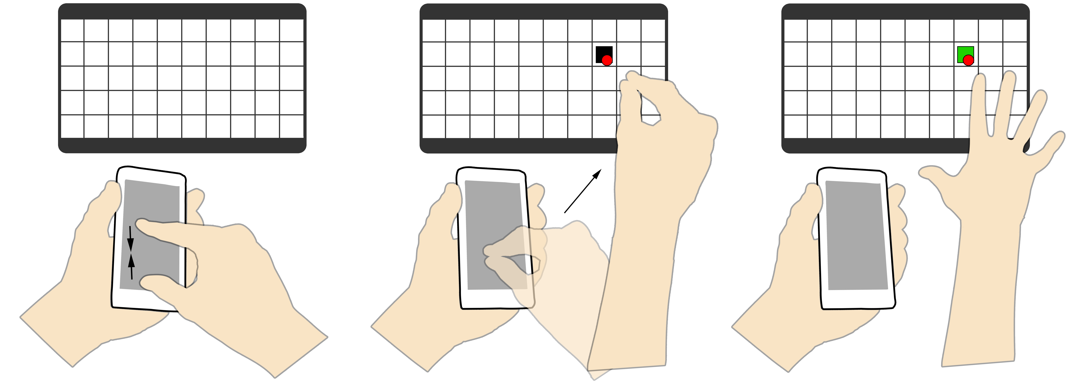

(a) (b) (c)

Figure 1. (a) First step of the Pinch technique is to make a pinch gesture on the phone using the index finger and thumb. (b) Second step is to move and use the pinched hand as a pointer. (c) Third step is to release by opening the hand.

The Swipe technique (Figure 2) is used by Bragdon et al. [4] in Code Space, a system using the Kinect and smartphones to support developer meetings. Bragdon et al. describe the technique as: “cross-device interaction with touch and air pointing” and the swipe motion is described as “flicking up on the touch screen”. This technique was chosen because of its simplistic design and the low level of complexity. Only one hand is needed and the amount of effort and time required to execute this technique is minimal compared to other tech- niques. Swipe is copied exactly as described in [4]. The Swipe technique is performed by 1) pointing at a target on the large display with the phone in a stretched arm, and 2) making a forwards swipe motion with the thumb on the phone’s screen (fig. 2).

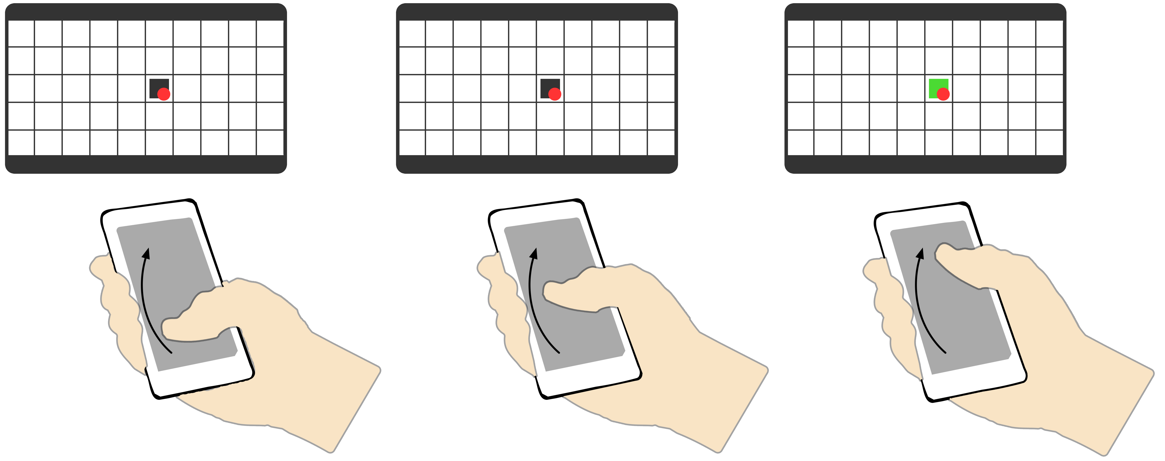

Table 1. This table describes the set of criteria.

|  |  |  |  |
| --- | --- | --- | --- |
| In the following we explain why these four techniques were chosen and how they should be performed. |  | | |
| The Pinch technique (Figure 1) is used in [8] by Ikematsu et |
| al., as part of a drag-and-drop method for moving data ob- |
| jects between devices. Chen et al. uses a pinching gesture in |
| [5] for cross-device interaction between a smartphone and a |
| smartwatch to control volume. Benko and Wilson [1] used the |
| Pinch technique for interacting with omnidirectional visual- | (a) | (b) | (c) |

izations in a dome. This technique is again a combination of

the pointing technique used by Scheible et al. [17] and the aforementioned pinching techniques. The reason for including this technique was to imitate the natural action of picking up a real object e.g. piece of paper, and then moving it to another location. With Pinch we get a two handed technique which requires the user to perform a series of steps and are thus considered more complex and time consuming than the one handed Swipe and Tilt. The Pinch technique is performed by

1) holding the phone in one hand and making a pinch gesture on the phone with the other hand (fig. 1a), subsequently clos- ing the hand; 2) pointing at a target on the large display with the closed hand (fig. 1b); and 3) opening the hand to complete the technique (fig. 1c).

Figure 2. The Swipe technique is performed by using the thumb to swipe

from (a) to (c).

The Throw technique (Figure 3) is a combination of a tech- nique for pointing [17] i.e. using a hand as a cursor in mid-air, and a throw technique described by Walter et al. [21] used in a system for sharing information on large public displays. We chose to include this technique based on its natural and playful design. The technique mimics the real world scenario of throwing something like a ball somewhere or to someone. Throw is two handed, more complex than aforementioned techniques, and takes a little longer to execute because of the increased number of steps. The Throw technique is performed by 1) pointing at a target on the large display with one hand (fig. 3a); 2) holding the phone in the other hand and selecting data (fig. 3b); and 3) making a swinging motion towards the large display (fig. 3c).

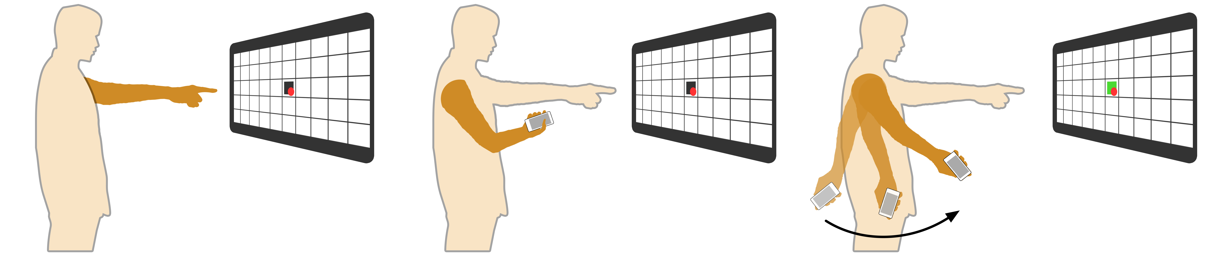

(a) (b) (c)

Figure 3. (a) First step of the Throw technique is to point at the screen. (b) Second step is to select data. (c) Third and final step is to do a swing- ing motion with the phone towards the screen.

The Tilt technique (Figure 4) is used in a collaborative appli- cation by Lucero et al. [9] to transfer an object from a large display to the user’s smartphone. Boring et al. [3] use the tilt technique when moving a pointer on a display using a phone and though not the same application, the execution of the tech- nique is the same. We chose this technique because it is one handed, relatively low complexity, and much like the Swipe it is generally easy to use. When the direction is reversed, Tilt is an exact copy of the way Lucero et al. describe the technique. The Tilt technique is performed by 1) pointing at a target on the large display with the phone in a stretched arm, and 2) making a forwards tilt with the phone (fig. 4).

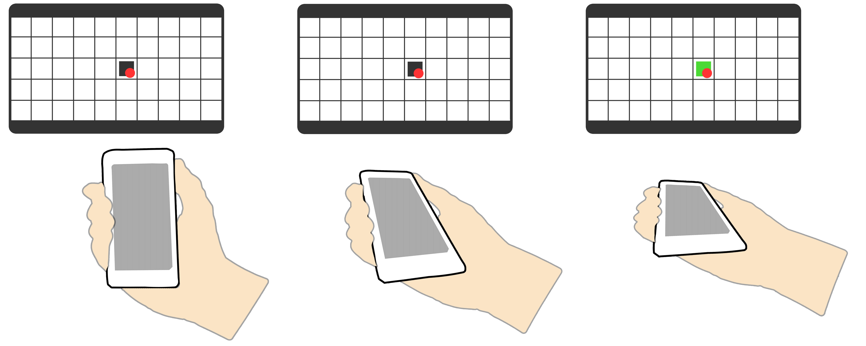

(a) (b) (c)

Figure 4. The Tilt technique is performed by doing a forward tilt motion with the phone from (a) to (c).

As mentioned, the techniques have been used in previously published papers where they were part of applications or sys- tems, facilitating interaction between devices such as phone to display interaction and vice versa. The described techniques are different in the way they are performed but also the number of hands that are required to make them work. We chose two techniques that are one-handed (Swipe and Tilt) and two tech- niques that are two-handed (Throw and Pinch). Also, to vary the complexity we chose two techniques that require more steps (Throw and Pinch), and two techniques that require less steps for the user to complete the technique (Swipe and Tilt).

All the techniques make use of some combination of pointing in mid-air and touch gestures on the smartphone screen. The mid-air pointing interaction is achieved by using the Microsoft Kinect for Windows which uses a depth camera making it possible to track a user’s hand in mid-air. As for the touch ges- tures, smartphones have an accelerometer and a touchscreen, making it possible to detect motion input and detect contact between e.g. a finger and the screen. These technologies are, in combination with each other, used to recognize the four techniques described in this section.

**EXPERIMENT**

The four cross-device interaction techniques mentioned above were implemented and then evaluated in a lab study in order to judge their performance compared to each other. We are interested in knowing whether or not the different techniques with different target sizes have an effect on the efficiency, accu- racy, and ease of use of pushing information to a large display. Therefore, we developed an application that would allow us to run experiments and test the effect of the different techniques and target sizes. We utilized a Microsoft Kinect, a 65’ inch Panasonic television with a 1920 × 1080 resolution and a Sam- sung Galaxy SII to create the experimental application. An overview of the experiment setup can be seen in Figure 5.

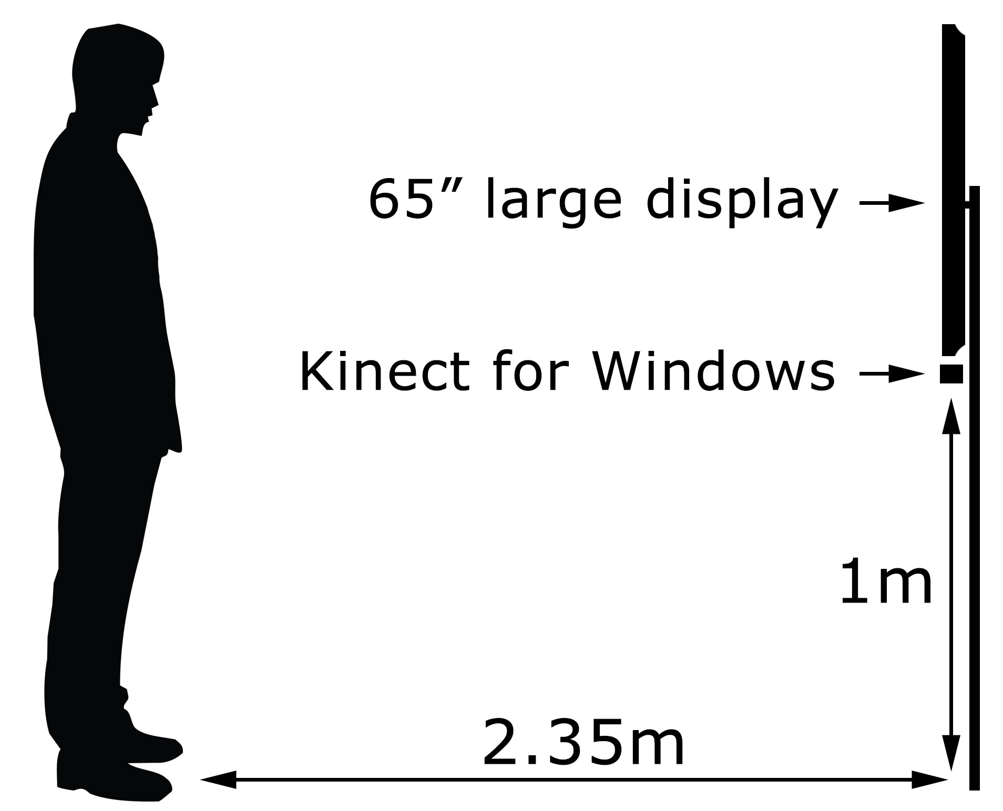

Figure 5. An overview of the entire setup of our experiment.

**Implementation**

The 4 techniques (Swipe, Tilt, Throw, and Pinch) were imple- mented in order to push data onto the large display. They were implemented in a simple and short target practice application, where the goal was to "hit" the target on the display with the shown technique.

A grid system was implemented in the test application, where each cell of the grid is a possible target. As mentioned, we were interested in measuring the effect of different target sizes on the different techniques, therefore the grid is implemented in two different sizes. The grid system can have large cells, where the grid is 5 × 10 cells and each cell is 61 pixels or 7.3 cm wide, or it could also have small cells, where the grid is

10 × 20 cells and each cell is 122 pixels, or 14.6 cm wide. The target is located in one of those cells, and scales accordingly to the size of the cell(See Figure 6a).

A red dot works as the pointer in the screen; it is the location that would be hit when the user performed the given technique. The yellow highlighted cell is the cell in which the pointer is currently located inside of. This is extra feedback for the user so that he knows exactly were he will hit once we performs the technique.

The developed mobile application was simple. It showed two shapes, a circle and a square, which the user could choose to push to the display. The display would tell which shape was the correct one by having that shape as the target in one of the grid cells. We chose two shapes so that it did not become a search problem with users spending too much time searching

for the correct shape. We wanted the user to spend some time orienting him or her self with the phone and not just simply performing the gesture without paying any attention to the phone at all. The phone screen can be seen in Figure 6b.

Users would control the pointer on the large display with their hands. Which ever hand was closest to the screen would determine the position of the pointer on the large screen. This meant that users could switch hands whenever they pleased at any point during the test.

The Pinch technique was implemented with the help of the Kinect and the touch screen on the mobile phone. This tech- nique started by having the user pinch the shape on the screen of the mobile phone and close his or her hand around it, as if to grab it. The Kinect would then look for a opening of the hand motion, on the pointer hand, and take that as the target point.

The Swipe technique was implemented with the touch screen of the phone. Here, we detected when a significant swipe happened on the screen, and then use the pointer location to place the shape that was swiped up onto the screen.

The Throw technique was also implemented with the help of the Kinect and the accelerometer on the mobile phone. The Kinect looked at the user to recognize when a user moved the mobile phone from 10 centimeters behind the hip to 10 centimeters in front of the hip. At the same time, the phone detects when a significant change in the accelerometer hap- pened, so to not simply detect an unintentional wave of the arm. The Kinect would then use the position of the other hand to see where on the screen the user intended to perform the Throw technique towards.

The Tilt technique was implemented mostly with the ac- celerometer of the phone, by checking for a significant change in the z and y axis of the accelerometer, as if tilting the phone forward.

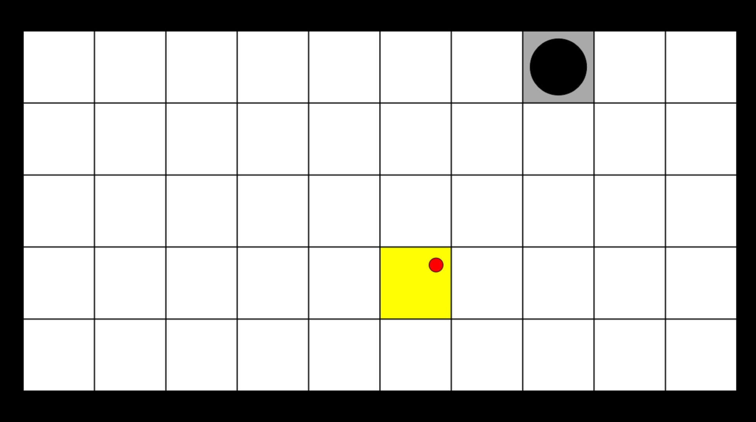

(a) (b)

Figure 6. (a) The large display screen of the application, with the red dot in the highlighted square as the starting point and the black circle as the target. (b) The phone screen showing the two shapes.

**Experimental Design**

The experiment was conducted as a within-subject research, with the four different interaction techniques and two target sizes as independent variables.

The within-subject research was chosen because we wanted to minimize the amount of subjects needed in order to get a significant result. We also believed that the learning effect

would not be as pronounced since the four techniques are very different from each other. We chose to investigate techniques because we were interested in learning about the way people interact with large displays, and the two target sizes to inves- tigate precision. Sometimes users need to be as precise as possible, and sometimes they just need to be able to interact with a large display.

For the dependent variables, different measures of completion time and hit success were used, as well as a short questionnaire to get the user’s satisfaction with regard to the given interaction technique. Which technique started the test was randomized in order to mitigate the learning effect on the entire set of tests. In the end, the Pinch gesture started 26.4% of all tests, Swipe started 22.7% of all tests, Throw started 24.5% of all tests, and Tilt started 26.4% of all tests. All of this was automatically logged, and every test session was also video recorded in order to be able to go through them in case we wanted to go into detail in one of the test sessions.

A simple logging mechanism was developed, which created a unique file for each user and outputted all attempts into that file. In the end, the result was a list of 53 files, one for each test participant, where each file would have a list of attempts and target size switches. Each attempt would have a time stamp, whether the user hit the target or not, whether he selected the correct shape, were the target was, and where the participant hit. These where the following measures that we were able to deduce from the log files that were generated:

Total Time: This was the time each user spent completing the test for a given interaction technique. This was measured from the time each user had hit his first target after a practice period of three tries until he had hit his last target. There were a total of 18 targets, plus the first target used for calibration.

Time per target: This was the time each user spent hitting each of the targets. This was measured as the time since each user last hit a target until he hit the next one.

Hit success: Whether or not each user hit the given target. Current pointer and target position (in both cell and pixels coordinates) were also recorded in order to give a precise measure of accuracy for each attempt in terms of distance to target.

Ease of use: Each user was given a questionnaire after having gone through each interaction technique. There were 6 ques- tions, all taken from the USE questionnaire [10]. These were asked to get an understanding of how useful and easy to use each technique was. The 6 questions were the following:

• It is easy to use

• Using it is effortless

• It is easy to learn to use

• I can use it successfully every time

• I quickly became skillful with it

• I learned how to use it quickly

Users were able to rate their answers to each question on a 7 point Likert scale. We also wrote down any comments made during the experiment and combined them with the questionnaire responses to get a better understanding of the user’s response to each of the techniques.

**Participants**

In total, 53 people took part in our experiment, which was conducted in a usability lab. The participants where between

20-45 years old (M: 24.4, SD: 4.3) and were between 1.63 and 1.95 meters tall (M: 1.82, SD:7.8). 88.7% of users were right handed, 90.6% were male, and 96.2% of them were smartphone users. Of those who owned smartphones, they had owned one for 2-15 years (M:5, SD:2.1). They were recruited through a mixture of our social network and recruit- ment posters around the campus.

**The Experiment**

Each test subject was taken into the usability lab and given a short introduction to what we were doing and why. We then explained how the system worked and what they had to do. We would hand them a phone, ask them to stand on a marked cross, so that the distance to the screen would always be the same, and start the test.

The application chose at random one of the four techniques and displayed a short explanatory movie of how to perform the technique on a screen right beside the main application display(See Figure 7a).

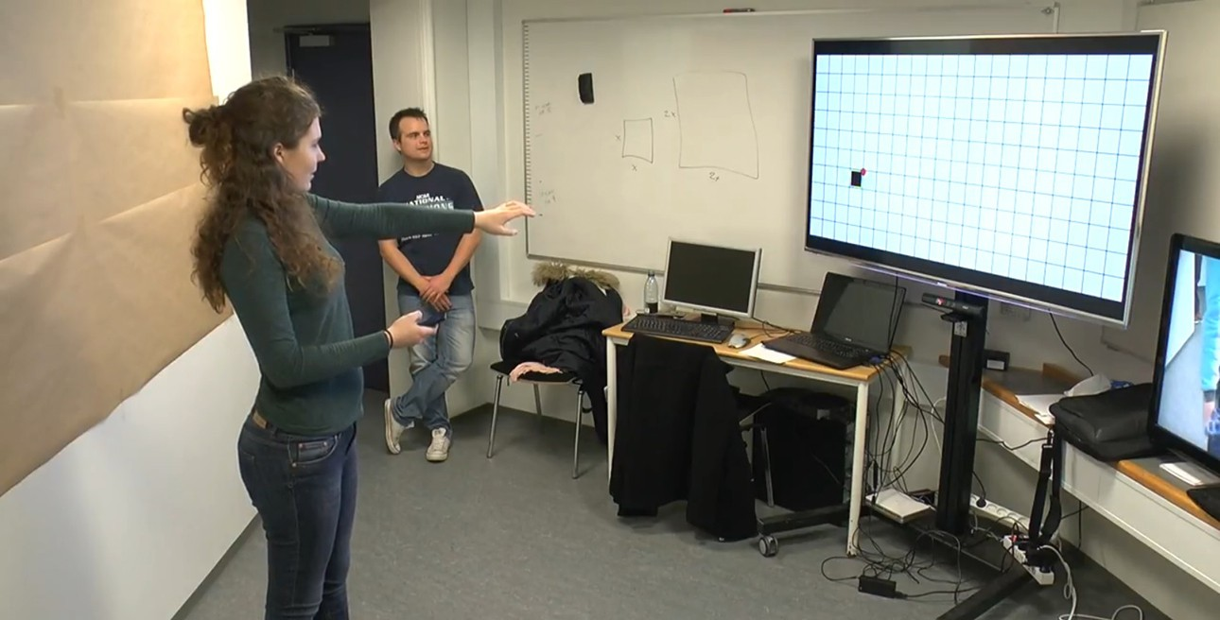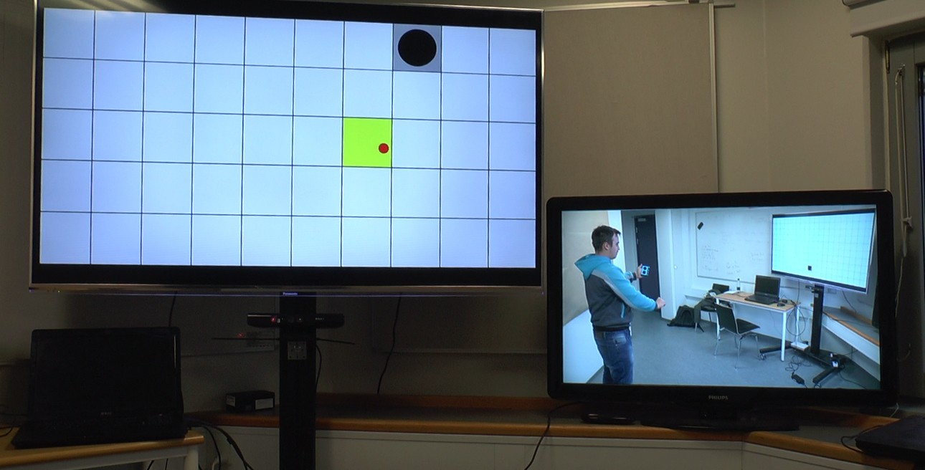

(a) (b)

Figure 7. (a) The main screen on the left with the tutorial video screen on the right. (b) The experiment in progress, as seen from the right.

The user would then have three practice attempts, in order to get familiar with the technique. Nothing was logged during the practice phase. A shape would appear, either a square or a circle, at one of the cells in the grid. The user would have to choose the correct shape on the phone and perform the technique with that shape selected. The shapes on the phone (fig. 6b) would randomly change positions, so that the user would have to check the phone after every technique. The target would also randomly change size from small to large or vice-versa. In reality, the target sequences where hard coded by us in such a way that there was an equal distribution of small and large targets. We also made sure that there was an equal distribution of distances between each target. We classified them as short jumps, medium jumps, and long jumps. A short jump was 2 large cells(4 small cells), a medium jump was 4 large cells(8 small cells), and a large jump was 6 large cells(12 small cells). After a practice phase of 3 practice targets, a calibration start target would be shown. This is so that we could calculate the distance between all other targets correctly.

The user would then go through the rest of the test (18 targets), going through a total of 22 targets.

That means that our experiment had the following list of con- ditions:

• Technique (4)

• Target size (2)

• Target jump distance (3)

• Repetition (3)

This means that each user had a total of 4 × 2 × 3 × 3 = 72 targets.

After going through every target for one technique, the user would then be asked to fill in the short questionnaire regarding the technique just tried in terms of how natural it felt based on ease of use measures.

This entire process would be repeated four times in total, once for each technique. After that, we presented them with a short demographics questionnaire, in order to better understand the user. We asked them about their age, height, if they were left or right handed, if they had a smartphone, for how long, if they had any experience with a Kinect, Wii, Playstation Move, or any other similar air gesture based technologies, and how often they used them. Finally, we thanked them for their time. The entire test took on average 15 minutes.

**RESULTS**

We will now present the results that we achieved through out our experiment and also how they were achieved. We will first present our findings in respect to success rate(based on hit success), then in respect to efficiency(based on time per target), and finally in respect to accuracy(based on distance to target). Finally, we will look at the questionnaires and show the significant findings there in terms of ease of use. We will discuss these results later, in the Discussion section. Each of the four interaction techniques, Pinch, Swipe, Throw and Tilt were completed 18 times per participant. For each target size, each technique was performed 477 times.

**Success Rate**

In this section we will present the results related to the success of hitting a target. We will perform an analysis of the hit success rate and the effect of each technique with respect to target sizes.

The success rate’s mean and standard deviation, M(St.D.) for each technique for small(S) and large(L) target sizes can be seen in Table 2 and in Figure 8 the results are shown as a graph.

Hit Success Means

|  |  |  |  |  |
| --- | --- | --- | --- | --- |
|  | Pinch  (n = 477) | Swipe  (n = 477) | Throw  (n = 477) | Tilt  (n = 477) |
| S | 0.65 (0.48) | 0.91 (0.29) | 0.83 (0.37) | 0.58 (0.49) |
| L | 0.78 (0.41) | 0.97 (0.18) | 0.94 (0.25) | 0.78 (0.41) |

Table 2. Mean hit and standard deviation for each technique per target for small(S) and large(L) targets.

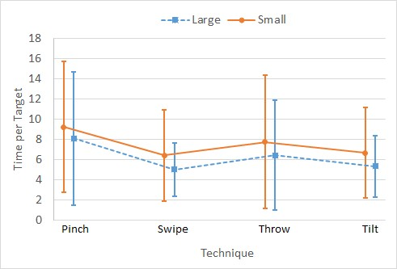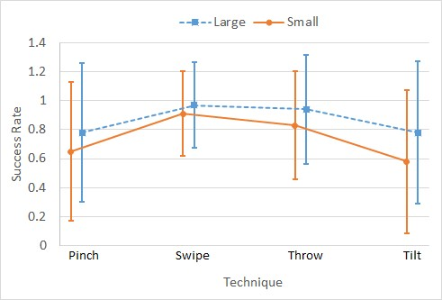

Figure 8. Mean and standard deviation for each technique in regards to hit success rate per target.

In order to see the effect of each technique on the hit ratio per target for the different target sizes, we performed two different one-way ANOVA’s, where we split the data between the two different target sizes. We then performed a post-hoc pairwise LSD test to see where the significant difference were.

For the the small target, we got ( p < 0.001), (F (2.722, 1295.674) = 62.754), (Greenhouse-Geisser correction: 0.907). The pairwise test showed that all techniques were significantly different. Pinch and Swipe had ( p < 0.001), Pinch and Throw ( p < 0.001), Pinch and Tilt ( p = 0.031), Swipe and Throw ( p = 0.001), Swipe and Tilt ( p < 0.001) and finally, Throw and Tilt had ( p < 0.001).

For the large target, we got ( p < 0.001), (F (2.472, 1176.749) = 42.773), (Greenhouse-Geisser correction: 0.824). The pairwise test showed that all of the techniques, with the exception of Pinch and Tilt, were statistically different from each other. The results were as following: Pinch and Swipe ( p < 0.001), Pinch and Throw ( p < 0.001), Pinch and Tilt ( p = 1.000), Swipe and Throw ( p = 0.025), Swipe and Tilt ( p < 0.001), and finally Throw and Tilt ( p < 0.001).

**Efficiency**

In this section we present the efficiency results which defines the amount of time spent performing a technique. We perform an analysis of the efficiency and the effect of each technique with respect to target sizes.

Table 3 shows the mean time per target in seconds for each of the techniques as well as their standard deviation for both target sizes.

|  |  |  |  |  |
| --- | --- | --- | --- | --- |
|  | Pinch  (n = 477) | Swipe  (n = 477) | Throw  (n = 477) | Tilt  (n = 477) |
| S | 9.23 (6.48) | 6.41 (4.49) | 7.73 (6.60) | 6.67 (4.49) |
| L | 8.09 (6.60) | 5.01 (2.66) | 6.42 (5.43) | 5.33 (3.04) |

Time per Target Means

Figure 9. Mean and standard deviation for each technique in regards to time per target.

To get the effect of each technique on the time for the different target sizes, we performed two one-way ANOVA’s, one for the small target and another for the large target. A post-hoc pairwise LSD test to see where the significant difference were.

For the the small target, we got ( p < 0.001), (F (2.740, 1304.290) = 26.523), (Greenhouse-Geisser correction: 0.913). The pairwise test showed that all techniques were significantly different except Swipe and Tilt. Pinch and Swipe had ( p < 0.001), Pinch and Throw ( p < 0.001), Pinch and Tilt ( p < 0.001), Swipe and Throw ( p < 0.001), Swipe and Tilt ( p = 0.354) and finally, Throw and Tilt had ( p = 0.004).

For the large target, we got ( p < 0.001), (F (2.221, 1057.144) = 44.539), (Greenhouse-Geisser correction: 0.740). The pairwise test showed that all of the techniques, with the exception of Swipe and Tilt, were statistically different from each other. The results were as following: Pinch and Swipe ( p < 0.001), Pinch and Throw ( p < 0.001), Pinch and Tilt ( p < 0.001), Swipe and Throw ( p < 0.001), Swipe and Tilt ( p = 0.077), and finally Throw and Tilt ( p < 0.001).

**Accuracy**

Finally, we will perform an analysis of the accuracy and the effect of each technique with respect to target sizes. Here, we took three different measures of accuracy; the distance between where the user hit and the target cell as well as taking the x and y axis independently. These were all measured in pixels. This was because there were signs that certain techniques might miss in a specific direction, and we wanted to see if the data supported that. An overview of the distance mean and standard deviation in pixels can be seen in Table 4 and Figure 10.

Table 3. Mean time and standard deviation for each technique per target for small(S) and large(L) targets.

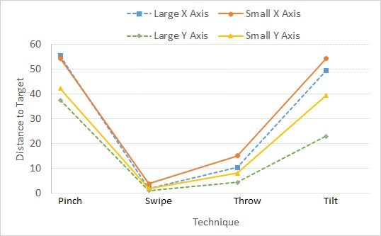

Figure 10. Mean and standard deviation for each technique in regards to distance.

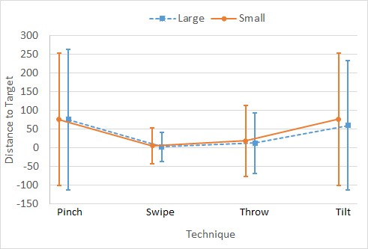

Distance Means

|  |  |  |  |  |
| --- | --- | --- | --- | --- |
|  | Pinch  (n = 477) | Swipe  (n = 477) | Throw  (n = 477) | Tilt  (n = 477) |
| S | 75.97 (176.15) | 5.40 (47.81) | 18.60 (95.29) | 76.51 (177.45) |
| L | 75.41 (187.58) | 2.29 (38.82) | 12.37 (81.36) | 59.88 (172.22) |

Table 4. Mean and standard deviation for the distance for each tech- nique per target for small(S) and large(L) targets.

We performed two one way ANOVA’s, one for each target size, on the distance data.

For the the small target, we got ( p < 0.001), (F (2.341, 1114.249) = 37.504), (Greenhouse-Geisser correction: 0.780). The pairwise test showed that all techniques were significantly different except Pinch and Tilt. Pinch and Swipe had ( p < 0.001), Pinch and Throw ( p < 0.001), Pinch and Tilt ( p = 0.961), Swipe and Throw ( p = 0.008), Swipe and Tilt ( p < 0.001) and finally, Throw and Tilt had ( p < 0.001).

For the large target, we got ( p < 0.001), (F (2.176, 1036.004) = 33.315), (Greenhouse-Geisser correction: 0.725). The pairwise test showed that all of the techniques, with the exception of Pinch and Tilt, were statistically different from each other. The results were as following: Pinch and Swipe had ( p < 0.001), Pinch and Throw ( p < 0.001), Pinch and Tilt ( p = 0.171), Swipe and Throw ( p = 0.015), Swipe and Tilt ( p < 0.001) and finally, Throw and Tilt had ( p < 0.001).

X and Y Distance Means

|  |  |  |  |  |
| --- | --- | --- | --- | --- |
|  | Pinch  (n = 477) | Swipe  (n = 477) | Throw  (n = 477) | Tilt |
| (n = 477) |
| S XD. | 54.33 (140.87) | 3.78 (40.15) | 10.32 (81.84) | 49.23 (151.36) |
| L XD. | 55.32 (159.88) | 1.88 (31.74) | 10.32 (74.01) | 49.23 (157.35) |
| S YD. | 42.90 (110.30) | 2.00 (26.16) | 8.00 (49.37) | 39.3 (99.82)3 |
| L YD. | 37.41 (104.18) | 1.14 (22.37) | 4.33 (34.21) | 22.86 (73.75) |

Table 5. Mean and standard deviation for distance on the X-Axis(XD) and distance on the Y-Axis(YD) for each technique per target for small(S) and large(L) targets.

Figure 11. Mean and standard deviation for each technique in regards distance on the x-axis and y-axis.

To get a better understanding of the distance we decided to examine the distance in regards to the x-axis and in regards to the y-axis. The results can be seen in Table 5 and Figure 11

**Results of Ease of Use Questionnaire**

Our questionnaire was based on USE, which used Likert scale

4.2, when encoding the data we did it as continuous variable, as such "strongly disagree" got a value of 1, and "strongly agree" a value ot 7. After that the cumulative value per technique, based on the different questions, was calculated, the data was ploted and presented in Figure 12.

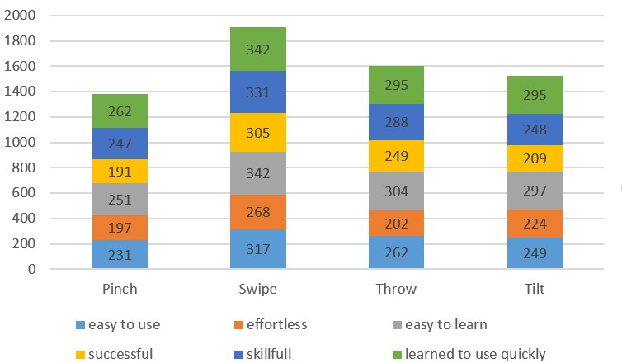

Figure 12. Cumulative values of survey questions per technique

A One-Way MANOVA was applied (F (18, 574.66) =

5.118, p < 0.000) which showed that there is statistical dif- ferences between each techniques. In order to specify where this differences lie we perform an post hoc test, we summa- rize the results in regards to each question from the survey, as follow: 1) “It is easy to use” Swipe is statistically differ- ent, however there is no statistical difference between Throw, Tilt, and Pinch; 2) “Using it is effortless” Swipe is statistically different, however there is no statistical difference between Throw, Tilt, and Pinch; 3) “It is easy to learn to use” Swipe and Pinch are statistically different, however there is no sta- tistical difference between Tilt, and Throw; 4) “I can use it

successfully every time” Swipe and Throw are statistically different, there is no statistical difference between Tilt, and Pinch; 5) “I quickly became skillful with it” Swipe and Throw are statistically different, however there is no statistical dif- ference between Pinch, and Tilt; 6) “I learned how to use it quickly” Swipe is statistically different, however there is no statistical difference between Throw, Tilt, and Pinch. The results show that the ratings received by the techniques differ in the different aspects of the areas covered by the survey.

**DISCUSSION**

When discussing our results, it is important to redefine the terms that we use. When talking about success rate, we mean whether or not the technique hit the given target. When we mention efficiency, we are talking about the time it takes to successfully perform that technique. When talking about accu- racy, we mean the distance the attempt was from the target(in pixels). It is also important to note that the standard deviation in some of our measures are quite high. This is primarily because the experimental system was not robust enough to get a perfect reading on the users intention to perform a technique. Sometimes, the system would misunderstand the gesture a user made, so that it either activated too early, or did not activate all. Activation means that the system interpreted the gestures the user performed as an attempt to hit the target. This is further discussed in Section 6.7

When looking at the results on the effect of the four techniques, Pinch, Swipe, Throw and Tilt, as well as the two target sizes, small and large, on the time per target, the results tell a rather interesting story.

**Success Rate**

If we look at the results in regards to the effect of the technique on the success rate of each attempt, it is interesting to note that the two techniques that were not significantly different from each other were Tilt and Pinch. These two techniques both used the hand that controlled the pointer to activate the technique. When tilting the phone forward, usually the hand would move together with the phone causing the pointer to dis- place itself from the users intended position. When releasing the Pinch, the Kinect would sometimes reevaluate the loca- tion of the hand joint, now that it could see the entire hand, which would also cause the pointer to displace itself from the intended position. Pinch and Tilt were also the techniques that had the largest amount of activation errors due to the im- plementation of the system. Sometimes, users would show large amount of their palms to the Kinect during a Pinch, even though their hand was closed, causing the Kinect to interpret that as an opening of the hand and activate the technique. Tilt would sometimes activate if the user moved the mobile around too quickly, especially when orienting the pointer up and down on the screen.

Swipe and Throw both had reasonably high success rates. Throw did not require the user to actually move the pointer hand while activating the technique. While Swipe did require the user to perform some movement on the hand that was used as a pointer, it was very little movement. This is also a technique all smartphone users are familiar with, since a

lot of applications use some form swiping to activate some functionality.

**Efficiency**

There was a significant difference between all techniques, with the exception of Swipe and Tilt. These were the two one handed techniques that we chose. The range of movement needed in order to activate these two techniques was rather limited, the full motion could be achieved quite quickly and is quite similar for both of them. This is why they are not statistically different from each other. Swipe and Tilt, are on average, at least a second faster then the other two techniques. Their standard deviations are also smaller, which means that users were more consistent, with regards to how long it took to hit each target, with these two techniques.

Looking at the two other techniques, Pinch and Throw, their times also reflect the range of motion needed in order to acti- vate each technique. Pinch requires the user to pinch the shape on their phone, lift their hand up, direct it on the screen, and then finally let go. This can be seen in its mean, where it takes almost 1.59 seconds longer to perform than the second longest technique, Throw. Throw also requires a considerable range of motion in order to activate: point with one arm, select the shape on the phone with the other arm, bring your arm back and then finally swing it forward. Both two handed techniques take significantly longer to perform than their one handed counter-parts.

We noticed that users would spent relatively little time get- ting into the general vicinity of the target, and would spend most of their time per attempt getting the pointer on top of the actual target. This was more pronounced for the small target, were users would perform smaller, more careful adjust- ments in order to not overshot the target, which can be seen when comparing the mean times of each technique for the two different target sizes.

**Accuracy**

If we look at the results regarding the distance from the target, it paints quite a clear image of which of the techniques are more accurate. Swipe is by far the most accurate of the four techniques. It is so precise, that it is actually more precise for the small target than all other techniques are for the large target. Figure 13 is an image that shows the location of each hit compared to the given target cell.

Figure 13 shows that Swipe and Throw have a large concen- tration of hits inside the target cell, where Pinch and Tilt have quite a spread of hits outside the target cell. This shows us that users are capable of hitting the target with Swipe and Throw more consistently and accurately than with the other two techniques by considerable amounts.

(a) (b) (c) (d)

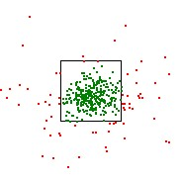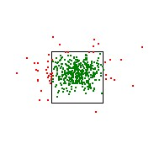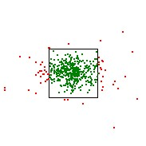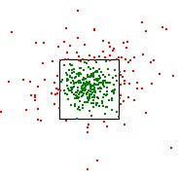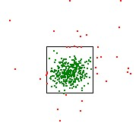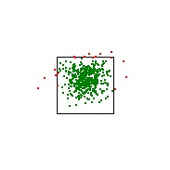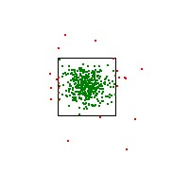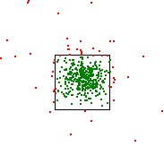

(e) (f) (g) (h)

Figure 13. Hit location illustration for each technique. Green is a hit, red is a miss (a) Pinch (Small target) (b) Swipe (Small target) (c) Throw (Small target) (d) Tilt (Small target) (e) Pinch (Large target) (f) Swipe (Large target) (g) Throw (Large target) (h) Tilt (Large target)

Also, an interesting thing to notice is that there is a trend where the largest distance from the target is located on the x axis. This can be seen in Table 5, where the distance is broken into the two different axis. For all four techniques, the x axis has a larger mean distance from the target then the y axis. Further research should be done though if one were to make some conclusive statement in regards to the effect of the different axis on the accuracy of the techniques.

**Target Size**

If we compare the effect of the target size on the different techniques, it does not have that big of an impact on the success rate of each technique compared to each other. Swipe and Throw are still the techniques with the highest success rate. Our results also show that target size does not change the efficiency of each technique compared to each other. The same is true for the distance from the target cell. Our results point towards a tendency were the size of the target does not influence the measured effectiveness of each technique relative to each other. This of course would require further research, since a sample size of two target sizes is not enough.

**Easy of Use**

Looking at the questionnaire, we can look at each question and see there is a trend. If the user gave it a high score, then he strongly agreed with the given question. We can then say the accumulated scores of each technique for all questions show a tendency towards the user agreeing that the given technique was easy to use and hence more natural to use. The higher the score, the easier the user felt the given technique was to perform. This means that in general, users considered Swipe much easier to use then the other techniques. Throw and Tilt were considerably close to each other, while Pinch trailed quite significantly behind. It is interesting to note that Throw and Tilt were so close to each other in ease of use, even though Throw outperformed Tilt considerably, both in regards to time and hit success, as well as the consistency of the technique, shown by the standard deviation.

**User Comments**

There is also a qualitative aspect to take into account here, which is not reflected well in the surveys or the test results, but were recorded on video and notes during each experiment. For example, a large finding was that correct mapping between the direction in which the user is pointing and the pointer icon on the screen is critical to the success of the application. It is extremely important for the experience of the user to have as close to absolute mapping as possible. Eleven users mentioned having trouble reaching all areas of the screen, but almost all users showed sign of trouble, by for example standing on their toes or stretching their arms as far as possible. One user got so frustrated that she asked for a chair to stand on. With more or different sensors, placed on hands, fingers and phones, we could have had a more precise pointer by being able to determine the direction of the phone and the arm and not solely rely on the position of the users hands. This would most likely lead to more precise results, because the the mapping between the pointer and the users pointing direction would be much closer to a absolute mapping.

In regards to the mobile phone, four users complained that the screen was too small when performing a Pinch, making it hard to precisely select the correct shape. Four other users complained that the screen was too large when performing a swipe, since it was hard to reach the correct shape with their thumbs while still maintaining precision with the pointer. Four users mentioned that it was hard to orient themselves with the phone while performing the Throw technique, having to break their flow to look down on the phone to select the correct shape. Three users mentioned the same problem with Swipe, whenever the targets were too high. This sometimes lead to the mobile phone covering up the target and making it hard for the user to orient themselves to the large display. This was an effect of the relative mapping though, since it was hard to see the screen when their arm was stretched far above their head in order to reach the high targets. The same error could have occurred with Tilt, since the user might also end up lifting the phone in front of their field of view, but none of the users mentioned it there.

There is also a the learning aspect of each technique. Six people actually mentioned that the Pinch technique was hard to learn, and a large portion of the participants had to be told more specifically how to perform it. The same held true for the Throw technique, a large number of the participants had to be told that they had to perform a slightly larger motion in order for the application to understand that a throw motion was being attempted. Very few of the participants had to have further instructions on how the Swipe technique worked, and few people needed further help with the Tilt. This is most likely a combination of the complexity of some of the techniques as well as the tutorial movies not being descriptive enough. This also lead to frustration, were users thought they were performing the technique correctly and nothing was happening. Four users mentioned being frustrated by the Pinch technique, while three users got frustrated with the Tilt technique

The fatigue effect is also something to take into consideration.

13 people mentioned being fatigued through out the test and 11

of them first mentioned it during the Throw technique. Some users commented that it was because one arm had nothing to do but be uplifted and point to the screen, while the other arm performed all the motion. One user mentioned it would not have been that noticeable if the pointing arm had some motion to perform. We have hopefully accounted for this by rotating the order in which the techniques are performed.

Finally, there is also the fun aspect to take into consideration. Nine users actually mentioned having fun while performing the Pinch technique. They compared it to casting a spell or causing explosions on the screen. Three other users mentioned that this technique was especially interesting. It is still worth remembering though that Pinch was, by large, the hardest technique for users to learn.

**Limitations**

There are of course some limitations to the system we devel- oped. Firstly, the intention with the Tilt technique was that the users would point and tilt with the phone, but because of our implementation, it was possible for users to point with one hand and tilt the phone with the other. The same holds true for the Swipe technique, where users were able to point with one hand and swipe with the other.

The way the system detects an open hand is not very robust: sometimes, depending on the profile of the hand, it misreads the users intentions and believes the user opened his hand.

The system also has a very narrow definition of what throwing means. This is something that can be seen when users were told to "throw" the data from the phone to the screen. Some would perform a much larger tilt motion, others would perform a baseball-like pitching motion.

The Kinect also had some problems determining where the different arm joints were. If the elbow joint was directly behind the hand joint from the Kinects perspective, it would cause the pointer to move erratically since the Kinect was not absolutely sure were the hand joint was. Another problem occurred when the user put their two hands close to each other. The Kinect would have problems determining where the individual hand joints were located.

**CONCLUSION**

We conducted a study on cross-device interaction techniques, where our focus was on pushing data from a mobile device onto a large display. We compared four different techniques (Pinch, Swipe, Throw and Tilt) with two different target sizes. Our main concern was investigating the success rate, efficiency, accuracy and ease of use of the user while using the different interaction techniques.

Our findings show that Swipe was the technique with the highest success rate, and at the same time, the most efficient and accurate technique. This was also the technique the users felt easiest to use. We also found that Pinch was considered to be a fun and entertaining technique by many of our users. Finally, we also found that the mapping between the screen and the users pointing direction is critical to the applications success. Great care should be taken to achieve as close to an absolute mapping as possible.

**FUTURE RESEARCH**

Based on our experiment, in which we used two target sizes, we can not determine the difference in effect between targets of different sizes on a large display. As such we would suggest more research including a greater varity of target sizes.

Whereas our experiment only consider push techniques, we would strongly suggest looking at pull techniques for cross- device natural user interaction with large displays. With pull techniques we imagine research investigating the opposite direction i.e. pulling information from a large display to a mobile device. The techniques which may be preferred for pushing information to a large display might not be the best choice for pulling information.

Our experiment has exclusively been concerned with specific measures like success rate, efficiency and accuracy for each technique, and we could suggest for future research that other measures be included in experiment. This includes, but is not limited to, measures on user experience and which techniques users prefer to use for interaction with displays located in public places.

We focused only on the interaction between mobile phones and large displays. In the future though, the range of different personal devices will probably be much more widespread than today, and we suggest further research in this area. An example of this research is the interaction between large displays and devices such as smart watches, tables, and smart glasses.

As a final suggestion, a framework for cross-device natural user interactions might help, for example, developers and researchers with techniques, guidelines and designs for inter- acting with large displays in the future.

**ACKNOWLEDGMENTS**

We would like to thank Jeni Paay for the excellent guidance we received throughout the entire project. We would like to thank Dimitrios Raptis for helping us set up the experiment as well as understanding all the data we got out of it. We would also like to thanks Jesper Kjeldskov for making sure we had all the resources we needed. Finally, we would like to thank all the test participants in our experiment.

**REFERENCES**

1. Hrvoje Benko and Andrew D. Wilson. 2010. Multi-point Interactions with Immersive Omnidirectional Visualizations in a Dome. In ACM International Conference on Interactive Tabletops and Surfaces (ITS

’10). ACM, New York, NY, USA, 19–28. DOI:

[http://dx.doi.org/10.1145/1936652.1936657](http://dx.doi.org/10.1145/)

2. Sebastian Boring, Manuela Altendorfer, Gregor Broll, Otmar Hilliges, and Andreas Butz. 2007. Shoot & Copy: Phonecam-based Information Transfer from Public Displays Onto Mobile Phones. In Proceedings of the 4th International Conference on Mobile Technology, Applications, and Systems and the 1st International Symposium on Computer Human Interaction in Mobile Technology (Mobility ’07). ACM, New York, NY, USA,

24–31. [DOI:http://dx.doi.org/10.1145/1378063.1378068](http://dx.doi.org/10.1145/)

3. Sebastian Boring, Marko Jurmu, and Andreas Butz. 2009.

Scroll, Tilt or Move It: Using Mobile Phones to Continuously Control Pointers on Large Public Displays. In Proceedings of the 21st Annual Conference of the Australian Computer-Human Interaction Special Interest Group: Design: Open 24/7 (OZCHI ’09). ACM, New York, NY, USA, 161–168. DOI: [http://dx.doi.org/10.1145/1738826.1738853](http://dx.doi.org/10.1145/)

4. Andrew Bragdon, Rob DeLine, Ken Hinckley, and Meredith Ringel Morris. 2011. Code Space: Touch + Air Gesture Hybrid Interactions for Supporting Developer Meetings. In Proceedings of the ACM International Conference on Interactive Tabletops and Surfaces (ITS

’11). ACM, New York, NY, USA, 212–221. DOI:

[http://dx.doi.org/10.1145/2076354.2076393](http://dx.doi.org/10.1145/)

5. Xiang ’Anthony’ Chen, Tovi Grossman, Daniel J.

Wigdor, and George Fitzmaurice. 2014. Duet: Exploring Joint Interactions on a Smart Phone and a Smart Watch. In Proceedings of the SIGCHI Conference on Human Factors in Computing Systems (CHI ’14). ACM, New York, NY, USA, 159–168. DOI: [http://dx.doi.org/10.1145/2556288.2556955](http://dx.doi.org/10.1145/)

6. Larry Francis. 1997. Mobile Computing: A Fact in Your Future. In Proceedings of the 15th Annual International Conference on Computer Documentation (SIGDOC ’97). ACM, New York, NY, USA, 63–67. DOI: [http://dx.doi.org/10.1145/263367.263378](http://dx.doi.org/10.1145/)

7. Peter Hamilton and Daniel J. Wigdor. 2014. Conductor: Enabling and Understanding Cross-device Interaction. In Proceedings of the SIGCHI Conference on Human Factors in Computing Systems (CHI ’14). ACM, New York, NY, USA, 2773–2782. DOI: [http://dx.doi.org/10.1145/2556288.2557170](http://dx.doi.org/10.1145/)

8. Kaori Ikematsu and Itiro Siio. 2015. Memory Stones: An

Intuitive Information Transfer Technique Between Multi-touch Computers. In Proceedings of the 16th International Workshop on Mobile Computing Systems and Applications (HotMobile ’15). ACM, New York, NY, USA, 3–8. DOI: [http://dx.doi.org/10.1145/2699343.2699352](http://dx.doi.org/10.1145/)

9. Andrés Lucero, Jussi Holopainen, and Tero Jokela. 2012.

MobiComics: Collaborative Use of Mobile Phones and Large Displays for Public Expression. In Proceedings of the 14th International Conference on Human-computer Interaction with Mobile Devices and Services (MobileHCI ’12). ACM, New York, NY, USA, 383–392. [DOI:http://dx.doi.org/10.1145/2371574.2371634](http://dx.doi.org/10.1145/)

10. AM Lund. 2001. Measuring Usability with the USE Questionnaire. STC Usability SIG Newsletter. (2001).

11. Nicolai Marquardt. 2011. Proxemic Interactions in Ubiquitous Computing Ecologies. In CHI ’11 Extended Abstracts on Human Factors in Computing Systems (CHI EA ’11). ACM, New York, NY, USA, 1033–1036. DOI: [http://dx.doi.org/10.1145/1979742.1979691](http://dx.doi.org/10.1145/)

12. Nicolai Marquardt, Ken Hinckley, and Saul Greenberg.

2012. Cross-device Interaction via Micro-mobility and F-formations. In Proceedings of the 25th Annual ACM Symposium on User Interface Software and Technology (UIST ’12). ACM, New York, NY, USA, 13–22. DOI: [http://dx.doi.org/10.1145/2380116.2380121](http://dx.doi.org/10.1145/)

13. Brad A. Myers. 2001. Using Handhelds and PCs Together. Commun. ACM 44, 11 (Nov. 2001), 34–41. [DOI:http://dx.doi.org/10.1145/384150.384159](http://dx.doi.org/10.1145/)

14. Heidi Selmer Nielsen, Marius Pallisgaard Olsen,

Mikael B. Skov, and Jesper Kjeldskov. 2014. JuxtaPinch: Exploring Multi-device Interaction in Collocated Photo Sharing. In Proceedings of the 16th International Conference on Human-computer Interaction with Mobile Devices &#38; Services (MobileHCI ’14). ACM, New York, NY, USA, 183–192. DOI: [http://dx.doi.org/10.1145/2628363.2628369](http://dx.doi.org/10.1145/)

15. Jun Rekimoto. 1997. Pick-and-drop: A Direct Manipulation Technique for Multiple Computer Environments. In Proceedings of the 10th Annual ACM Symposium on User Interface Software and Technology (UIST ’97). ACM, New York, NY, USA, 31–39. DOI: [http://dx.doi.org/10.1145/263407.263505](http://dx.doi.org/10.1145/)

16. Jun Rekimoto. 1998. Multiple-Computer User Interfaces: A Cooperative Environment Consisting of Multiple Digital Devices. In Proceedings of the First International Workshop on Cooperative Buildings, Integrating Information, Organization, and Architecture (CoBuild

’98). Springer-Verlag, London, UK, UK, 33–40.

[http://dl.acm.org/citation.cfm?id=645968.674728](http://dl.acm.org/citation.cfm)

17. Jürgen Scheible, Timo Ojala, and Paul Coulton. 2008.

MobiToss: A Novel Gesture Based Interface for Creating and Sharing Mobile Multimedia Art on Large Public Displays. In Proceedings of the 16th ACM International Conference on Multimedia (MM ’08). ACM, New York, NY, USA, 957–960. DOI: [http://dx.doi.org/10.1145/1459359.1459532](http://dx.doi.org/10.1145/)

18. Dominik Schmidt, Julian Seifert, Enrico Rukzio, and Hans Gellersen. 2012. A Cross-device Interaction Style for Mobiles and Surfaces. In Proceedings of the Designing Interactive Systems Conference (DIS ’12). ACM, New York, NY, USA, 318–327. DOI: [http://dx.doi.org/10.1145/2317956.2318005](http://dx.doi.org/10.1145/)

19. Julian Seifert, Adalberto Simeone, Dominik Schmidt, Paul Holleis, Christian Reinartz, Matthias Wagner, Hans Gellersen, and Enrico Rukzio. 2012. MobiSurf: Improving Co-located Collaboration Through Integrating Mobile Devices and Interactive Surfaces. In Proceedings of the 2012 ACM International Conference on Interactive Tabletops and Surfaces (ITS ’12). ACM, New York, NY, USA, 51–60. DOI: [http://dx.doi.org/10.1145/2396636.2396644](http://dx.doi.org/10.1145/)

20. Mikael B. Skov, Jesper Kjeldskov, Jeni Paay, Heidi P.

Jensen, and Marius P. Olsen. 2015. Investigating

Cross-Device Interaction Techniques: A Case of Card Playing on Handhelds and Tablets. In Proceedings of the Annual Meeting of the Australian Special Interest Group for Computer Human Interaction (OzCHI ’15). ACM, New York, NY, USA, 446–454. DOI: [http://dx.doi.org/10.1145/2838739.2838763](http://dx.doi.org/10.1145/)

21. Robert Walter, Gilles Bailly, Nina Valkanova, and Jörg Müller. 2014. Cuenesics: Using Mid-air Gestures to Select Items on Interactive Public Displays. In Proceedings of the 16th International Conference on Human-computer Interaction with Mobile Devices &#38; Services (MobileHCI ’14). ACM, New York, NY, USA,

299–308. DOI:

[http://dx.doi.org/10.1145/2628363.2628368](http://dx.doi.org/10.1145/)

Concluding Remarks

The work we did this semester ended with two scientific papers as products.

The two papers give us an increased understanding of working and developing ap- plications for cross-device interactions with regards to large public displays and mobile devices. We learned about the challenges of creating successful, efficient and accu- rate cross-device interaction techniques that feel natural for the users to perform, in a way that they are capable of walking up to the display and performing the technique with as little guidance as possible.

We did this by developing four techniques and developing an experiment around them where we analyze the hit rate, time per target and distance from target for each of these techniques. We also measured the naturalness of each technique by listening to users comment throughout our experiment, as well as asking them to fill out a small ease of use questionnaire for each technique.

These two papers have built a foundation for our work next semester, were we might use one of the techniques to develop a working application or further explore the tech- niques we have developed in different contexts or different measures of success.

41

APPENDICES

Contents

Appendix A: Questionnaire . . . . . . . . . . . . . . . . . . . . . . . . III Appendix B: Demographic Questionnaire . . . . . . . . . . . . . . . . V Appendix C: Questionnaire Results . . . . . . . . . . . . . . . . . . . . VII Appendix D: Demographic Questionnaire Results . . . . . . . . . . . . XIII Appendix E: Example of raw comment log . . . . . . . . . . . . . . . . XV Appendix F: Example of raw test log . . . . . . . . . . . . . . . . . . .XVII Appendix G: Recruitment Poster . . . . . . . . . . . . . . . . . . . . . XXI Appendix H: Pictures . . . . . . . . . . . . . . . . . . . . . . . . . . X. XIII

2016

AALBORG UNIVERSITY

I

Appendix A: Questionnaire



**It is easy to use**

I strongly disagree I strongly agree



**Using it is effortless**

I strongly disagree I strongly agree



**It is easy to learn to use it**

I strongly disagree I strongly agree



**I can use it successfully every time**

I strongly disagree I strongly agree



**I quickly became skillful with it**

I strongly disagree I strongly agree



**I learned to use it quickly**

I strongly disagree I strongly agree



Appendix B: Demographic Questionnaire

Gesture Test

Age:

Gender: Height: Left or right handed: Left Right

Smartphone user: Yes No

How long have you had one? What device do you currently own?

Have you ever played any motion sensor based games such Wii

games, Kinect games, or PlayStation Move games?

Yes No

|  |  |  |  |
| --- | --- | --- | --- |
| How often? | Daily |  | Once a week |
|  | Once a month |  | Other: |

Appendix C: Questionnaire Results

|  |  |  |  |  |  |  |  |
| --- | --- | --- | --- | --- | --- | --- | --- |
|  | ID E | asy_to_us | effortless a | sy_to_lear | successful | skillfull | learned_to_use_quickly |
| Swipe | 1 | 4 | 2 | 4 | 6 | 7 | 5 |
| Tilt | 1 | 5 | 5 | 6 | 3 | 6 | 5 |
| Throw | 1 | 2 | 2 | 6 | 3 | 7 | 6 |
| Pinch | 1 | 5 | 5 | 5 | 3 | 7 | 6 |
| Swipe | 2 | 5 | 5 | 6 | 5 | 6 | 7 |
| Tilt | 2 | 4 | 6 | 6 | 5 | 5 | 6 |
| Throw | 2 | 4 | 3 | 5 | 3 | 4 | 5 |
| Pinch | 2 | 6 | 6 | 5 | 7 | 6 | 6 |
| Swipe | 3 | 3 | 3 | 3 | 2 | 3 | 3 |
| Tilt | 3 | 6 | 5 | 6 | 5 | 5 | 6 |
| Throw | 3 | 3 | 3 | 2 | 3 | 4 | 2 |
| Pinch | 3 | 5 | 6 | 5 | 3 | 4 | 3 |
| Swipe | 4 | 7 | 7 | 7 | 5 | 6 | 6 |
| Tilt | 4 | 5 | 3 | 4 | 4 | 4 | 5 |
| Throw | 4 | 5 | 4 | 5 | 4 | 4 | 6 |
| Pinch | 4 | 2 | 2 | 2 | 1 | 3 | 2 |
| Swipe | 5 | 4 | 4 | 7 | 6 | 6 | 7 |
| Tilt | 5 | 6 | 6 | 7 | 6 | 6 | 7 |
| Throw | 5 | 1 | 2 | 2 | 2 | 2 | 2 |
| Pinch | 5 | 2 | 3 | 2 | 2 | 2 | 2 |
| Swipe | 6 | 6 | 6 | 7 | 6 | 7 | 7 |
| Tilt | 6 | 6 | 6 | 7 | 6 | 6 | 7 |
| Throw | 6 | 6 | 4 | 6 | 6 | 5 | 4 |
| Pinch | 6 | 2 | 2 | 5 | 1 | 2 | 3 |
| Swipe | 7 | 6 | 3 | 7 | 6 | 7 | 6 |
| Tilt | 7 | 3 | 2 | 3 | 2 | 3 | 4 |
| Throw | 7 | 5 | 3 | 5 | 5 | 6 | 5 |
| Pinch | 7 | 1 | 1 | 2 | 2 | 2 | 2 |
| Swipe | 8 | 7 | 5 | 7 | 6 | 7 | 7 |
| Tilt | 8 | 6 | 4 | 6 | 3 | 6 | 6 |
| Throw | 8 | 6 | 4 | 6 | 5 | 6 | 7 |
| Pinch | 8 | 6 | 4 | 7 | 2 | 6 | 7 |
| Swipe | 9 | 7 | 4 | 7 | 6 | 6 | 7 |
| Tilt | 9 | 4 | 4 | 5 | 4 | 4 | 5 |
| Throw | 9 | 6 | 4 | 5 | 6 | 7 | 7 |
| Pinch | 9 | 5 | 4 | 7 | 4 | 6 | 7 |
| Swipe | 10 | 7 | 3 | 7 | 7 | 6 | 7 |
| Tilt | 10 | 5 | 2 | 6 | 5 | 4 | 5 |
| Throw | 10 | 3 | 3 | 5 | 1 | 5 | 7 |
| Pinch | 10 | 6 | 2 | 7 | 6 | 6 | 6 |
| Swipe | 11 | 6 | 5 | 7 | 6 | 7 | 7 |
| Tilt | 11 | 7 | 6 | 7 | 6 | 7 | 7 |
| Throw | 11 | 4 | 5 | 5 | 4 | 7 | 5 |
| Pinch | 11 | 7 | 6 | 7 | 4 | 7 | 7 |
| Swipe | 12 | 5 | 3 | 5 | 7 | 6 | 5 |
| Tilt | 12 | 3 | 2 | 6 | 4 | 5 | 6 |

VII

|  |  |  |  |  |  |  |  |
| --- | --- | --- | --- | --- | --- | --- | --- |
| Throw | 12 | 2 | 1 | 3 | 3 | 5 | 4 |
| Pinch | 12 | 4 | 2 | 4 | 6 | 6 | 4 |
| Swipe | 13 | 6 | 3 | 5 | 6 | 6 | 5 |
| Tilt | 13 | 6 | 4 | 6 | 5 | 5 | 6 |
| Throw | 13 | 4 | 2 | 5 | 2 | 3 | 4 |
| Pinch | 13 | 5 | 4 | 6 | 2 | 3 | 6 |
| Swipe | 14 | 3 | 4 | 6 | 5 | 6 | 6 |
| Tilt | 14 | 6 | 5 | 6 | 5 | 5 | 7 |
| Throw | 14 | 5 | 3 | 6 | 4 | 3 | 5 |
| Pinch | 14 | 5 | 2 | 6 | 2 | 4 | 5 |
| Swipe | 15 | 7 | 7 | 7 | 6 | 6 | 7 |
| Tilt | 15 | 2 | 5 | 3 | 2 | 2 | 4 |
| Throw | 15 | 3 | 2 | 5 | 4 | 5 | 5 |
| Pinch | 15 | 4 | 3 | 6 | 4 | 5 | 6 |
| Swipe | 16 | 7 | 6 | 7 | 7 | 7 | 7 |
| Tilt | 16 | 5 | 2 | 6 | 5 | 5 | 5 |
| Throw | 16 | 6 | 4 | 7 | 7 | 7 | 6 |
| Pinch | 16 | 5 | 3 | 3 | 3 | 5 | 4 |
| Swipe | 17 | 7 | 7 | 7 | 7 | 7 | 7 |
| Tilt | 17 | 6 | 5 | 7 | 3 | 4 | 4 |
| Throw | 17 | 7 | 6 | 7 | 6 | 7 | 7 |
| Pinch | 17 | 3 | 2 | 3 | 2 | 3 | 4 |
| Swipe | 18 | 7 | 5 | 6 | 6 | 7 | 7 |
| Tilt | 18 | 6 | 3 | 7 | 5 | 7 | 6 |
| Throw | 18 | 5 | 2 | 6 | 6 | 6 | 5 |
| Pinch | 18 | 5 | 2 | 4 | 3 | 6 | 5 |
| Swipe | 19 | 6 | 7 | 7 | 7 | 7 | 7 |
| Tilt | 19 | 5 | 5 | 6 | 4 | 5 | 6 |
| Throw | 19 | 6 | 3 | 6 | 6 | 6 | 7 |
| Pinch | 19 | 5 | 4 | 5 | 4 | 5 | 5 |
| Swipe | 20 | 6 | 5 | 6 | 5 | 4 | 5 |
| Tilt | 20 | 6 | 5 | 7 | 6 | 7 | 6 |
| Throw | 20 | 7 | 6 | 7 | 7 | 6 | 6 |
| Pinch | 20 | 5 | 4 | 6 | 2 | 5 | 6 |
| Swipe | 21 | 6 | 6 | 6 | 5 | 6 | 7 |
| Tilt | 21 | 5 | 3 | 6 | 3 | 6 | 6 |
| Throw | 21 | 3 | 2 | 4 | 2 | 6 | 4 |
| Pinch | 21 | 6 | 6 | 6 | 6 | 7 | 7 |
| Swipe | 22 | 7 | 7 | 7 | 7 | 7 | 7 |
| Tilt | 22 | 5 | 5 | 6 | 4 | 6 | 7 |
| Throw | 22 | 6 | 6 | 7 | 5 | 7 | 7 |
| Pinch | 22 | 7 | 6 | 7 | 6 | 7 | 7 |
| Swipe | 23 | 7 | 7 | 7 | 7 | 7 | 7 |
| Tilt | 23 | 5 | 5 | 6 | 6 | 6 | 6 |
| Throw | 23 | 3 | 4 | 5 | 5 | 6 | 6 |
| Pinch | 23 | 5 | 5 | 4 | 1 | 4 | 5 |
| Swipe | 24 | 7 | 5 | 7 | 6 | 7 | 7 |

VIII

|  |  |  |  |  |  |  |  |
| --- | --- | --- | --- | --- | --- | --- | --- |
| Tilt | 24 | 2 | 3 | 3 | 1 | 3 | 3 |
| Throw | 24 | 5 | 3 | 6 | 6 | 6 | 7 |
| Pinch | 24 | 6 | 4 | 7 | 3 | 5 | 7 |
| Swipe | 25 | 4 | 1 | 6 | 3 | 5 | 6 |
| Tilt | 25 | 4 | 1 | 6 | 5 | 6 | 6 |
| Throw | 25 | 2 | 1 | 5 | 3 | 3 | 4 |
| Pinch | 25 | 6 | 1 | 6 | 6 | 6 | 5 |
| Swipe | 26 | 6 | 5 | 6 | 6 | 6 | 6 |
| Tilt | 26 | 5 | 5 | 5 | 2 | 4 | 6 |
| Throw | 26 | 4 | 4 | 5 | 2 | 4 | 3 |
| Pinch | 26 | 3 | 3 | 2 | 3 | 3 | 2 |
| Swipe | 27 | 7 | 7 | 7 | 7 | 7 | 7 |
| Tilt | 27 | 6 | 6 | 7 | 5 | 7 | 7 |
| Throw | 27 | 5 | 5 | 6 | 5 | 6 | 6 |
| Pinch | 27 | 3 | 4 | 5 | 5 | 5 | 6 |
| Swipe | 28 | 7 | 2 | 7 | 5 | 6 | 7 |
| Tilt | 28 | 3 | 3 | 3 | 4 | 2 | 4 |
| Throw | 28 | 5 | 3 | 7 | 4 | 6 | 5 |
| Pinch | 28 | 6 | 2 | 7 | 5 | 7 | 7 |
| Swipe | 29 | 7 | 7 | 7 | 7 | 7 | 7 |
| Tilt | 29 | 6 | 6 | 7 | 6 | 7 | 7 |
| Throw | 29 | 7 | 7 | 7 | 5 | 7 | 7 |
| Pinch | 29 | 4 | 2 | 3 | 2 | 3 | 3 |
| Swipe | 30 | 7 | 6 | 7 | 7 | 7 | 7 |
| Tilt | 30 | 3 | 3 | 5 | 2 | 2 | 6 |
| Throw | 30 | 3 | 2 | 6 | 2 | 4 | 6 |
| Pinch | 30 | 3 | 3 | 4 | 4 | 2 | 4 |
| Swipe | 31 | 6 | 4 | 6 | 7 | 6 | 6 |
| Tilt | 31 | 6 | 4 | 6 | 6 | 6 | 6 |
| Throw | 31 | 3 | 2 | 5 | 4 | 5 | 5 |
| Pinch | 31 | 2 | 4 | 2 | 3 | 3 | 3 |
| Swipe | 32 | 7 | 6 | 7 | 5 | 5 | 7 |
| Tilt | 32 | 7 | 7 | 7 | 6 | 7 | 7 |
| Throw | 32 | 7 | 6 | 7 | 7 | 7 | 7 |
| Pinch | 32 | 5 | 5 | 4 | 6 | 6 | 4 |
| Swipe | 33 | 5 | 3 | 7 | 6 | 6 | 7 |
| Tilt | 33 | 6 | 4 | 7 | 5 | 6 | 6 |
| Throw | 33 | 6 | 5 | 7 | 5 | 6 | 7 |
| Pinch | 33 | 5 | 4 | 5 | 2 | 4 | 6 |
| Swipe | 34 | 7 | 6 | 7 | 5 | 7 | 7 |
| Tilt | 34 | 5 | 5 | 6 | 3 | 5 | 6 |
| Throw | 34 | 6 | 3 | 7 | 6 | 6 | 7 |
| Pinch | 34 | 2 | 2 | 4 | 1 | 3 | 3 |
| Swipe | 35 | 6 | 3 | 6 | 6 | 6 | 6 |
| Tilt | 35 | 3 | 2 | 3 | 4 | 3 | 5 |
| Throw | 35 | 5 | 3 | 5 | 3 | 6 | 6 |
| Pinch | 35 | 6 | 3 | 5 | 6 | 5 | 6 |

IX

|  |  |  |  |  |  |  |  |
| --- | --- | --- | --- | --- | --- | --- | --- |
| Swipe | 36 | 6 | 6 | 7 | 5 | 6 | 6 |
| Tilt | 36 | 2 | 2 | 3 | 1 | 4 | 4 |
| Throw | 36 | 5 | 4 | 5 | 4 | 5 | 5 |
| Pinch | 36 | 5 | 4 | 5 | 3 | 4 | 5 |
| Swipe | 37 | 5 | 4 | 6 | 5 | 6 | 6 |
| Tilt | 37 | 3 | 3 | 4 | 2 | 2 | 3 |
| Throw | 37 | 7 | 6 | 7 | 6 | 6 | 6 |
| Pinch | 37 | 3 | 4 | 4 | 5 | 6 | 5 |
| Swipe | 38 | 7 | 7 | 7 | 7 | 7 | 7 |
| Tilt | 38 | 4 | 4 | 7 | 4 | 5 | 5 |
| Throw | 38 | 7 | 6 | 7 | 6 | 7 | 7 |
| Pinch | 38 | 7 | 6 | 7 | 6 | 7 | 7 |
| Swipe | 39 | 6 | 3 | 7 | 3 | 4 | 6 |
| Tilt | 39 | 3 | 5 | 5 | 2 | 2 | 5 |
| Throw | 39 | 4 | 2 | 7 | 7 | 6 | 5 |
| Pinch | 39 | 1 | 1 | 3 | 1 | 1 | 3 |
| Swipe | 40 | 6 | 4 | 7 | 6 | 5 | 6 |
| Tilt | 40 | 4 | 1 | 2 | 1 | 1 | 2 |
| Throw | 40 | 4 | 5 | 5 | 4 | 3 | 3 |
| Pinch | 40 | 2 | 1 | 1 | 3 | 1 | 4 |
| Swipe | 41 | 6 | 5 | 6 | 6 | 6 | 6 |
| Tilt | 41 | 3 | 3 | 5 | 3 | 3 | 4 |
| Throw | 41 | 6 | 5 | 5 | 5 | 4 | 4 |
| Pinch | 41 | 3 | 3 | 4 | 2 | 3 | 3 |
| Swipe | 42 | 6 | 6 | 7 | 7 | 7 | 6 |
| Tilt | 42 | 3 | 3 | 5 | 5 | 5 | 5 |
| Throw | 42 | 6 | 5 | 6 | 7 | 6 | 7 |
| Pinch | 42 | 6 | 6 | 7 | 7 | 7 | 7 |
| Swipe | 43 | 6 | 7 | 7 | 6 | 7 | 7 |
| Tilt | 43 | 5 | 6 | 6 | 3 | 4 | 7 |
| Throw | 43 | 7 | 5 | 7 | 6 | 7 | 7 |
| Pinch | 43 | 3 | 4 | 5 | 2 | 4 | 4 |
| Swipe | 44 | 3 | 5 | 4 | 2 | 3 | 6 |
| Tilt | 44 | 3 | 6 | 6 | 1 | 1 | 6 |
| Throw | 44 | 4 | 2 | 6 | 7 | 5 | 5 |
| Pinch | 44 | 2 | 3 | 3 | 5 | 4 | 2 |
| Swipe | 45 | 5 | 5 | 6 | 6 | 7 | 7 |
| Tilt | 45 | 6 | 6 | 7 | 3 | 5 | 7 |
| Throw | 45 | 6 | 4 | 6 | 6 | 7 | 7 |
| Pinch | 45 | 2 | 6 | 3 | 1 | 5 | 6 |
| Swipe | 46 | 6 | 6 | 7 | 5 | 7 | 7 |
| Tilt | 46 | 2 | 3 | 4 | 1 | 1 | 4 |
| Throw | 46 | 5 | 3 | 6 | 3 | 4 | 5 |
| Pinch | 46 | 6 | 5 | 6 | 4 | 4 | 6 |
| Swipe | 47 | 7 | 6 | 7 | 7 | 7 | 7 |
| Tilt | 47 | 7 | 5 | 7 | 6 | 7 | 7 |
| Throw | 47 | 7 | 3 | 7 | 6 | 7 | 7 |

X

|  |  |  |  |  |  |  |  |
| --- | --- | --- | --- | --- | --- | --- | --- |
| Pinch | 47 | 5 | 6 | 5 | 5 | 5 | 6 |
| Swipe | 48 | 7 | 7 | 7 | 7 | 7 | 7 |
| Tilt | 48 | 4 | 4 | 4 | 3 | 3 | 4 |
| Throw | 48 | 7 | 6 | 7 | 7 | 7 | 7 |
| Pinch | 48 | 7 | 7 | 7 | 7 | 7 | 7 |
| Swipe | 49 | 7 | 5 | 7 | 6 | 7 | 7 |
| Tilt | 49 | 7 | 6 | 7 | 6 | 7 | 7 |
| Throw | 49 | 5 | 3 | 7 | 6 | 6 | 7 |
| Pinch | 49 | 4 | 4 | 3 | 4 | 5 | 4 |
| Swipe | 50 | 5 | 5 | 6 | 4 | 6 | 5 |
| Tilt | 50 | 6 | 5 | 5 | 5 | 6 | 6 |
| Throw | 50 | 6 | 5 | 6 | 5 | 6 | 6 |
| Pinch | 50 | 4 | 3 | 3 | 2 | 4 | 5 |
| Swipe | 51 | 6 | 6 | 7 | 6 | 7 | 7 |
| Tilt | 51 | 3 | 3 | 7 | 5 | 6 | 6 |
| Throw | 51 | 5 | 5 | 5 | 5 | 4 | 4 |
| Pinch | 51 | 4 | 4 | 6 | 6 | 7 | 7 |
| Swipe | 52 | 5 | 5 | 6 | 5 | 6 | 6 |
| Tilt | 52 | 6 | 6 | 6 | 5 | 5 | 6 |
| Throw | 52 | 6 | 5 | 6 | 4 | 5 | 6 |
| Pinch | 52 | 3 | 3 | 4 | 1 | 3 | 4 |
| Swipe | 53 | 6 | 7 | 6 | 6 | 7 | 7 |
| Tilt | 53 | 5 | 6 | 7 | 3 | 4 | 6 |
| Throw | 53 | 5 | 6 | 6 | 4 | 3 | 5 |
| Pinch | 53 | 7 | 6 | 7 | 5 | 7 | 6 |

XI

Appendix D: Demographic Questionnaire Results

|  |  |  |  |  |  |  |  |  |  |
| --- | --- | --- | --- | --- | --- | --- | --- | --- | --- |
| ID | Age | Gender | Height | Handed | Smartphone | Years | Current | Experience | How_Often |
| 1 | 24 | m | 174 | r | y | 5 | Iphone | y | Once a month |
| 2 | 24 | m | 183 | r | y | 7.5 | Samsung note II | y | 3-4 times ever |
| 3 | 23 | m | 172 | r | n | n | None | y | One a year |
| 4 | 24 | m | 180 | r | y | 2 | Nexus 5 | y | Sometimes |
| 5 | 24 | m | 179 | r | y | 7 | Iphone 4s | y | Once a month |
| 6 | 24 | m | 183 | r | y | 4 | Iphone | y | Sometimes |
| 7 | 26 | m | 185 | r | y | 5 | Huawei P8 Lite | y | Every second year |
| 8 | 25 | m | 182 | r | y | 10 | Iphone | y | 4 times |
| 9 | 23 | f | 164 | r | y | 4.5 | Iphone | y | Sometimes |
| 10 | 23 | m | 178 | r | y | 5 | Sony Xperia Z1 | y | Once a week, years ago |
| 11 | 23 | m | 190 | l | y | 6 | Galaxy S4 | y | Once a month |
| 12 | 26 | m | 185 | r | y | 2 | LG G2 | y | Single time |
| 13 | 23 | m | 167 | r | y | 6 | Samsung galaxy S5 | y | Long time ago |
| 14 | 40 | f | 169 | r | y | 5 | One Plus 1 | y | Few times a year |
| 15 | 25 | m | 193 | r | y | 6 | Galaxy S3 | n | Never |
| 16 | 21 | m | 182 | r | y | 5 | Samsung S4 mini | y | Other |
| 17 | 23 | f | 172 | r | y | 8 | Sony Xperia Z3 Compact | y | Once a month |
| 18 | 23 | m | 191 | r | y | 5 | One Plus 1 | y | Once a month |
| 19 | 25 | m | 187 | r | y | 4 | One Plus 2 | y | Once a year |
| 20 | 23 | m | 183 | r | y | 8 | Iphone 6 | y | Few times a year |
| 21 | 20 | f | 177 | r | y | 5 | Samsung galaxy S4 mini | y | 2 times a year |
| 22 | 23 | m | 180 | r | y | 5 | Nokia lumia 920 | y | Daily |
| 23 | 24 | m | 188 | r | y | 5 | Iphone 6 | y | Once a month |
| 24 | 22 | m | 183 | r | y | 5 | Samsung galaxy s6 edge | y | Rarely |
| 25 | 23 | m | 167 | r | y | 6 | One plus 1 | y | years ago |
| 26 | 23 | m | 165 | r | y | 6 | One plus 1 | y | Twice a year |
| 27 | 23 | m | 186 | r | y | 5 | One plus 2 | y | Once or twice a year |
| 28 | 34 | m | 178 | r | y | 6 | One plus 1 | y | Last year |
| 29 | 24 | f | 180 | r | y | 7 | Huawei Honor 6 | y | Once every few months |
| 30 | 24 | m | 172 | l | y | 4.5 | One plus 1 | y | Long time ago |
| 31 | 21 | m | 185 | r | y | 6 | Samsung galaxy s5 | y | Sometime, a year ago |
| 32 | 21 | m | 195 | l | y | 4 | Iphone 4s | y | Around 10 times |
| 33 | 22 | m | 187 | l | y | 5 | Nexus 5 | y | 2-4 times a year |
| 34 | 21 | m | 192 | r | y | 5 | Huwai p8 lite | y | Special occasions |
| 35 | 22 | m | 188 | r | y | 6 | Iphone 5s | y | Twice a year, long ago |
| 36 | 21 | m | 175 | r | y | 5 | Iphone 6 | y | Once a month |
| 37 | 26 | m | 173 | r | y | 7 | Iphone 6s | y | Once a week |
| 38 | 26 | m | 182 | l | y | 5 | Iphone 5 | y | Once a year |
| 39 | 28 | m | 183 | r | y | 2 | ? | y | Not anymore |
| 40 | 20 | m | 180 | r | y | 3 | Sony Xperia c1505 | y | Rarely |
| 41 | 29 | m | 186 | r | y | 11 | Iphone | n | Never |
| 42 | 45 | m | 167 | r | y | 5 | Iphone 4s | n | Never |
| 43 | 22 | m | 183 | l | y | 5 | Iphone 5s | y | Once a week |
| 44 | 22 | m | 183 | r | n | n | Nokia | y | Used to play |
| 45 | 23 | m | 163 | r | y | 4 | Samsung | n | Never |
| 46 | 22 | m | 187 | r | y | 15 | LG G3 | y | 3 years ago |

XIII

|  |  |  |  |  |  |  |  |  |  |
| --- | --- | --- | --- | --- | --- | --- | --- | --- | --- |
| 47 | 22 | m | 186 | r | y | 5 | iPhone | y | Once a month |
| 48 | 24 | m | 171 | r | y | 6 | Sony Xperia | n | Never |
| 49 | 25 | m | 169 | r | y | 5 | Iphone 6 | y | 3 times |
| 50 | 24 | m | 180 | r | y | 6 | Samsung galaxy s6 | n | Never |
| 51 | 24 | m | 183 | r | y | 5 | Xiaomi | y | Several times |
| 52 | 26 | m | 180 | r | y | 4 | Nexus 5 | y | Twice a year |
| 53 | 25 | m | 180 | r | y | 3.5 | Iphone 4s | y | Almost never |

XIV

Appendix E: Example of raw comment log

Tilt:

- Shared some accidental recognitions

Pinch:

- Few start issues with undestanding the technique

- After that, and the technique was understood, everything looked good

Swipe:

- No questions about the technique

- No problems

- Was paying more attention to the video this time then previously

Throw:

- The video is not clear about the motion

(the fact that you have to do a bigger gesture)

XV

XVII

Appendix F: Example of raw test log

Participant #24 [17:25:28]: Started new gesture test. Type: Pinch Direction: Push

[17:25:28]: Changed grid size. Grid height: 5 Grid width: 10 Cell height: 122.8 Cell width: 121.4 [17:26:06]: Changed grid size. Grid height: 10 Grid width: 20 Cell height: 61.4 Cell width: 60.7 [17:26:25]: Target: Hit Shape: Correct TC: (12,05) CC: (12, 05) JL: NA Pointer position: (742.2,333.1).

[17:26:31]: Target: Miss Shape: Correct TC: (07,02) CC: (08, 02) JL: Short Pointer position: (535.2,135.0). [17:26:32]: Changed grid size. Grid height: 5 Grid width: 10 Cell height: 122.8 Cell width: 121.4

[17:26:50]: Target: Miss Shape: Correct TC: (07,04) CC: (09, 00) JL: Medium Pointer position: (1214.0,63.1). [17:26:51]: Changed grid size. Grid height: 10 Grid width: 20 Cell height: 61.4 Cell width: 60.7

[17:26:56]: Target: Hit Shape: Correct TC: (02,03) CC: (02, 03) JL: Long Pointer position: (152.6,228.1). [17:27:05]: Target: Hit Shape: Correct TC: (16,03) CC: (16, 03) JL: Long Pointer position: (1019.4,223.0). [17:27:06]: Changed grid size. Grid height: 5 Grid width: 10 Cell height: 122.8 Cell width: 121.4

[17:27:11]: Target: Hit Shape: Correct TC: (03,03) CC: (03, 03) JL: Medium Pointer position: (394.2,440.8). [17:27:21]: Target: Hit Shape: Correct TC: (09,00) CC: (09, 00) JL: Long Pointer position: (1180.3,63.0). [17:27:28]: Target: Hit Shape: Correct TC: (07,02) CC: (07, 02) JL: Short Pointer position: (920.1,291.8). [17:27:29]: Changed grid size. Grid height: 10 Grid width: 20 Cell height: 61.4 Cell width: 60.7

[17:27:49]: Target: Hit Shape: Correct TC: (05,02) CC: (05, 02) JL: Medium Pointer position: (344.2,154.9). [17:27:57]: Target: Hit Shape: Correct TC: (09,06) CC: (09, 06) JL: Short Pointer position: (590.6,415.1). [17:28:05]: Target: Hit Shape: Correct TC: (19,07) CC: (19, 07) JL: Medium Pointer position: (1188.1,453.6). [17:28:06]: Changed grid size. Grid height: 5 Grid width: 10 Cell height: 122.8 Cell width: 121.4

[17:28:14]: Target: Hit Shape: Correct TC: (07,01) CC: (07, 01) JL: Short Pointer position: (928.1,181.7). [17:28:20]: Target: Hit Shape: Correct TC: (01,04) CC: (01, 04) JL: Long Pointer position: (134.3,550.2). [17:28:27]: Target: Hit Shape: Correct TC: (03,02) CC: (03, 02) JL: Short Pointer position: (415.4,314.4). [17:28:28]: Changed grid size. Grid height: 10 Grid width: 20 Cell height: 61.4 Cell width: 60.7

[17:28:48]: Target: Hit Shape: Correct TC: (16,02) CC: (16, 02) JL: Medium Pointer position: (997.4,151.3). [17:28:52]: Target: Miss Shape: Correct TC: (16,08) CC: (14, 08) JL: Short Pointer position: (904.1,514.6). [17:28:54]: Changed grid size. Grid height: 5 Grid width: 10 Cell height: 122.8 Cell width: 121.4

[17:29:11]: Target: Hit Shape: Correct TC: (01,02) CC: (01, 02) JL: Long Pointer position: (198.7,287.3). [17:29:12]: Changed grid size. Grid height: 10 Grid width: 20 Cell height: 61.4 Cell width: 60.7 [17:29:29]: Target: Hit Shape: Correct TC: (16,01) CC: (16, 01) JL: Long Pointer position: (1005.3,77.4). [17:29:30]: Changed grid size. Grid height: 5 Grid width: 10 Cell height: 122.8 Cell width: 121.4

[17:29:35]: Target: Hit Shape: Correct TC: (03,02) CC: (03, 02) JL: Medium Pointer position: (440.5,282.3). [17:30:24]: Started new gesture test. Type: Swipe Direction: Push

[17:30:44]: Changed grid size. Grid height: 10 Grid width: 20 Cell height: 61.4 Cell width: 60.7

XVIII

Participant #24

[17:30:56]: Changed grid size. Grid height: 5 Grid width: 10 Cell height: 122.8 Cell width: 121.4 [17:30:58]: Target: Hit Shape: Correct TC: (02,02) CC: (02, 02) JL: NA Pointer position: (302.3,272.9). [17:31:12]: Target: Hit Shape: Correct TC: (07,01) CC: (07, 01) JL: Medium Pointer position: (933.7,136.1). [17:31:13]: Changed grid size. Grid height: 10 Grid width: 20 Cell height: 61.4 Cell width: 60.7

[17:31:36]: Target: Miss Shape: Correct TC: (13,08) CC: (14, 07) JL: Short Pointer position: (899.4,481.3). [17:31:40]: Target: Miss Shape: Correct TC: (18,05) CC: (19, 05) JL: Short Pointer position: (1156.9,353.5). [17:31:41]: Changed grid size. Grid height: 5 Grid width: 10 Cell height: 122.8 Cell width: 121.4

[17:31:44]: Target: Hit Shape: Correct TC: (02,00) CC: (02, 00) JL: Long Pointer position: (325.0,63.5). [17:31:45]: Changed grid size. Grid height: 10 Grid width: 20 Cell height: 61.4 Cell width: 60.7

[17:31:53]: Target: Hit Shape: Correct TC: (12,07) CC: (12, 07) JL: Medium Pointer position: (776.0,464.5). [17:32:00]: Target: Hit Shape: Correct TC: (03,03) CC: (03, 03) JL: Medium Pointer position: (224.4,207.5). [17:32:01]: Changed grid size. Grid height: 5 Grid width: 10 Cell height: 122.8 Cell width: 121.4

[17:32:16]: Target: Miss Shape: Correct TC: (08,03) CC: (09, 03) JL: Long Pointer position: (1116.9,372.2). [17:32:22]: Target: Hit Shape: Correct TC: (05,02) CC: (05, 02) JL: Short Pointer position: (659.8,270.2). [17:32:30]: Target: Hit Shape: Correct TC: (02,03) CC: (02, 03) JL: Short Pointer position: (341.1,378.7). [17:32:31]: Changed grid size. Grid height: 10 Grid width: 20 Cell height: 61.4 Cell width: 60.7

[17:32:38]: Target: Miss Shape: Correct TC: (17,01) CC: (16, 01) JL: Long Pointer position: (1031.4,90.8). [17:32:53]: Target: Hit Shape: Correct TC: (06,08) CC: (06, 08) JL: Long Pointer position: (416.9,507.9). [17:32:54]: Changed grid size. Grid height: 5 Grid width: 10 Cell height: 122.8 Cell width: 121.4

[17:32:57]: Target: Hit Shape: Correct TC: (07,02) CC: (07, 02) JL: Medium Pointer position: (918.9,333.5). [17:32:58]: Changed grid size. Grid height: 10 Grid width: 20 Cell height: 61.4 Cell width: 60.7

[17:33:02]: Target: Hit Shape: Correct TC: (01,02) CC: (01, 02) JL: Long Pointer position: (101.6,148.7). [17:33:03]: Changed grid size. Grid height: 5 Grid width: 10 Cell height: 122.8 Cell width: 121.4

[17:33:06]: Target: Hit Shape: Correct TC: (05,02) CC: (05, 02) JL: Medium Pointer position: (677.3,291.5). [17:33:07]: Changed grid size. Grid height: 10 Grid width: 20 Cell height: 61.4 Cell width: 60.7

[17:33:10]: Target: Hit Shape: Correct TC: (16,07) CC: (16, 07) JL: Short Pointer position: (1016.5,462.3). [17:33:11]: Changed grid size. Grid height: 5 Grid width: 10 Cell height: 122.8 Cell width: 121.4

[17:33:14]: Target: Hit Shape: Correct TC: (01,01) CC: (01, 01) JL: Long Pointer position: (220.3,158.2). [17:33:15]: Changed grid size. Grid height: 10 Grid width: 20 Cell height: 61.4 Cell width: 60.7

[17:33:18]: Target: Hit Shape: Correct TC: (12,06) CC: (12, 06) JL: Medium Pointer position: (765.4,383.7). [17:33:19]: Changed grid size. Grid height: 5 Grid width: 10 Cell height: 122.8 Cell width: 121.4

[17:33:21]: Target: Hit Shape: Correct TC: (03,02) CC: (03, 02) JL: Short Pointer position: (411.5,307.0). [17:33:52]: Started new gesture test. Type: Throw Direction: Push

XIX

Participant #24

[17:34:24]: Changed grid size. Grid height: 10 Grid width: 20 Cell height: 61.4 Cell width: 60.7 [17:34:38]: Target: Hit Shape: Correct TC: (15,03) CC: (15, 03) JL: NA Pointer position: (961.0,223.3). [17:34:45]: Target: Hit Shape: Correct TC: (06,07) CC: (06, 07) JL: Medium Pointer position: (395.1,456.5). [17:34:55]: Target: Hit Shape: Correct TC: (03,02) CC: (03, 02) JL: Short Pointer position: (210.6,172.2). [17:34:56]: Changed grid size. Grid height: 5 Grid width: 10 Cell height: 122.8 Cell width: 121.4

[17:35:01]: Target: Hit Shape: Correct TC: (08,03) CC: (08, 03) JL: Long Pointer position: (1051.3,405.1). [17:35:06]: Target: Hit Shape: Correct TC: (06,00) CC: (06, 00) JL: Short Pointer position: (785.9,94.7). [17:35:07]: Changed grid size. Grid height: 10 Grid width: 20 Cell height: 61.4 Cell width: 60.7

[17:35:10]: Target: Miss Shape: Correct TC: (06,05) CC: (07, 05) JL: Medium Pointer position: (432.8,319.8). [17:35:11]: Changed grid size. Grid height: 5 Grid width: 10 Cell height: 122.8 Cell width: 121.4

[17:35:11]: Target: Miss Shape: Correct TC: (08,03) CC: (03, 02) JL: Medium Pointer position: (412.3,334.2). [17:35:12]: Changed grid size. Grid height: 10 Grid width: 20 Cell height: 61.4 Cell width: 60.7

[17:35:17]: Target: Hit Shape: Correct TC: (03,03) CC: (03, 03) JL: Long Pointer position: (211.7,218.9). [17:35:23]: Target: Hit Shape: Correct TC: (06,08) CC: (06, 08) JL: Short Pointer position: (392.5,522.6). [17:35:24]: Changed grid size. Grid height: 5 Grid width: 10 Cell height: 122.8 Cell width: 121.4 [17:35:32]: Target: Miss Shape: Correct TC: (00,01) CC: (01, 02) JL: Long Pointer position: (161.0,249.1). [17:35:33]: Changed grid size. Grid height: 10 Grid width: 20 Cell height: 61.4 Cell width: 60.7

[17:35:40]: Target: Hit Shape: Correct TC: (05,00) CC: (05, 00) JL: Long Pointer position: (332.1,19.0). [17:35:45]: Target: Hit Shape: Correct TC: (14,04) CC: (14, 04) JL: Medium Pointer position: (873.3,270.4). [17:35:46]: Changed grid size. Grid height: 5 Grid width: 10 Cell height: 122.8 Cell width: 121.4

[17:35:50]: Target: Hit Shape: Correct TC: (00,04) CC: (00, 04) JL: Long Pointer position: (44.4,556.1). [17:35:51]: Changed grid size. Grid height: 10 Grid width: 20 Cell height: 61.4 Cell width: 60.7 [17:35:56]: Target: Hit Shape: Correct TC: (14,06) CC: (14, 06) JL: Long Pointer position: (880.9,389.8). [17:35:57]: Changed grid size. Grid height: 5 Grid width: 10 Cell height: 122.8 Cell width: 121.4

[17:35:58]: Target: Miss Shape: Wrong TC: (02,01) CC: (06, 02) JL: Medium Pointer position: (791.2,343.2). [17:36:03]: Target: Hit Shape: Correct TC: (04,03) CC: (04, 03) JL: Short Pointer position: (517.1,408.0). [17:36:07]: Target: Hit Shape: Correct TC: (07,03) CC: (07, 03) JL: Short Pointer position: (894.8,419.8). [17:36:09]: Changed grid size. Grid height: 10 Grid width: 20 Cell height: 61.4 Cell width: 60.7

[17:36:16]: Target: Hit Shape: Correct TC: (13,01) CC: (13, 01) JL: Short Pointer position: (808.0,75.1). [17:36:17]: Changed grid size. Grid height: 5 Grid width: 10 Cell height: 122.8 Cell width: 121.4

[17:36:21]: Target: Hit Shape: Correct TC: (02,03) CC: (02, 03) JL: Medium Pointer position: (291.8,419.2). [17:36:59]: Started new gesture test. Type: Tilt Direction: Push

[17:37:22]: Changed grid size. Grid height: 10 Grid width: 20 Cell height: 61.4 Cell width: 60.7

XX

Participant #24

[17:37:27]: Changed grid size. Grid height: 5 Grid width: 10 Cell height: 122.8 Cell width: 121.4 [17:37:30]: Target: Hit Shape: Correct TC: (08,01) CC: (08, 01) JL: NA Pointer position: (1006.7,213.7). [17:37:31]: Target: Miss Shape: Correct TC: (03,00) CC: (08, 01) JL: Medium Pointer position: (988.3,193.8). [17:37:32]: Changed grid size. Grid height: 10 Grid width: 20 Cell height: 61.4 Cell width: 60.7

[17:37:33]: Target: Miss Shape: Wrong TC: (18,08) CC: (08, 02) JL: Long Pointer position: (499.7,156.4). [17:37:37]: Target: Miss Shape: Correct TC: (04,06) CC: (04, 05) JL: Long Pointer position: (293.8,347.6). [17:37:38]: Changed grid size. Grid height: 5 Grid width: 10 Cell height: 122.8 Cell width: 121.4 [17:37:43]: Target: Hit Shape: Correct TC: (03,00) CC: (03, 00) JL: Short Pointer position: (448.1,73.2). [17:37:44]: Changed grid size. Grid height: 10 Grid width: 20 Cell height: 61.4 Cell width: 60.7

[17:37:44]: Target: Miss Shape: Wrong TC: (14,07) CC: (07, 01) JL: Medium Pointer position: (463.3,80.6). [17:37:45]: Changed grid size. Grid height: 5 Grid width: 10 Cell height: 122.8 Cell width: 121.4 [17:37:56]: Target: Hit Shape: Correct TC: (00,01) CC: (00, 01) JL: Long Pointer position: (72.6,170.3). [17:38:01]: Target: Hit Shape: Correct TC: (07,01) CC: (07, 01) JL: Long Pointer position: (957.0,152.6). [17:38:02]: Changed grid size. Grid height: 10 Grid width: 20 Cell height: 61.4 Cell width: 60.7

[17:38:10]: Target: Hit Shape: Wrong TC: (10,06) CC: (10, 06) JL: Short Pointer position: (653.5,389.0). [17:38:12]: Target: Miss Shape: Wrong TC: (18,00) CC: (15, 03) JL: Medium Pointer position: (963.5,185.5). [17:38:13]: Changed grid size. Grid height: 5 Grid width: 10 Cell height: 122.8 Cell width: 121.4

[17:38:13]: Target: Miss Shape: Correct TC: (02,02) CC: (08, 01) JL: NA Pointer position: (1043.4,137.3). [17:38:14]: Changed grid size. Grid height: 10 Grid width: 20 Cell height: 61.4 Cell width: 60.7 [17:38:18]: Target: Miss Shape: Correct TC: (08,00) CC: (09, 00) JL: Short Pointer position: (583.3,0.0).

[17:38:20]: Target: Miss Shape: Correct TC: (15,07) CC: (09, 00) JL: Medium Pointer position: (553.5,20.4). [17:38:26]: Target: Miss Shape: Correct TC: (02,02) CC: (01, 02) JL: Long Pointer position: (95.2,157.5). [17:38:27]: Changed grid size. Grid height: 5 Grid width: 10 Cell height: 122.8 Cell width: 121.4

[17:38:34]: Target: Hit Shape: Wrong TC: (05,03) CC: (05, 03) JL: Medium Pointer position: (669.0,439.2). [17:38:35]: Changed grid size. Grid height: 10 Grid width: 20 Cell height: 61.4 Cell width: 60.7

[17:38:42]: Target: Hit Shape: Correct TC: (15,03) CC: (15, 03) JL: Short Pointer position: (941.0,213.0). [17:38:43]: Changed grid size. Grid height: 5 Grid width: 10 Cell height: 122.8 Cell width: 121.4 [17:38:49]: Target: Hit Shape: Wrong TC: (05,03) CC: (05, 03) JL: Short Pointer position: (686.3,427.6). [17:38:53]: Target: Miss Shape: Wrong TC: (01,00) CC: (02, 00) JL: Medium Pointer position: (251.8,98.5). [17:39:04]: Target: Hit Shape: Correct TC: (04,01) CC: (04, 01) JL: Short Pointer position: (511.0,151.8).

Appendix G: Recruitment Poster

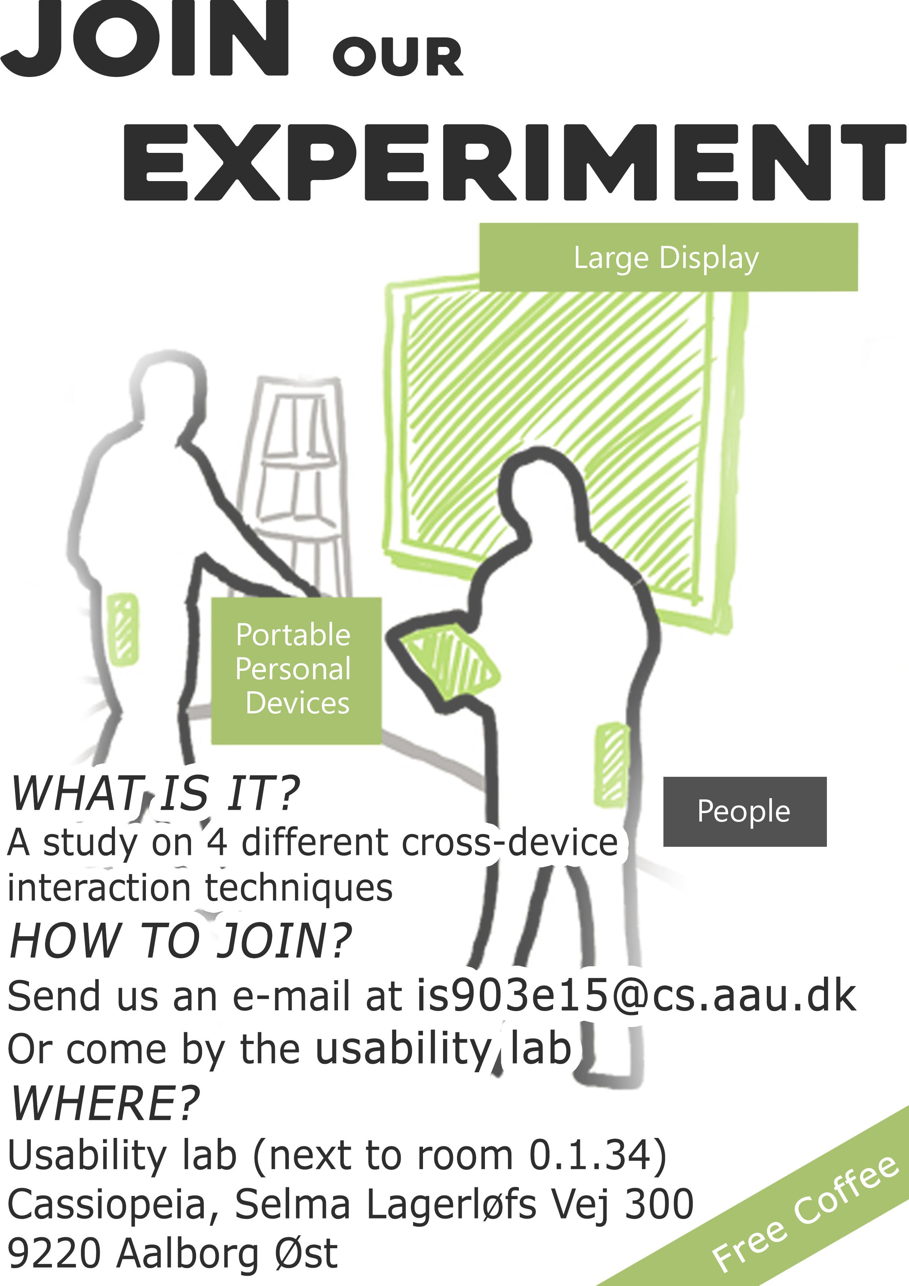

XXI

Appendix H: Pictures

Setup



Presenting the experiment

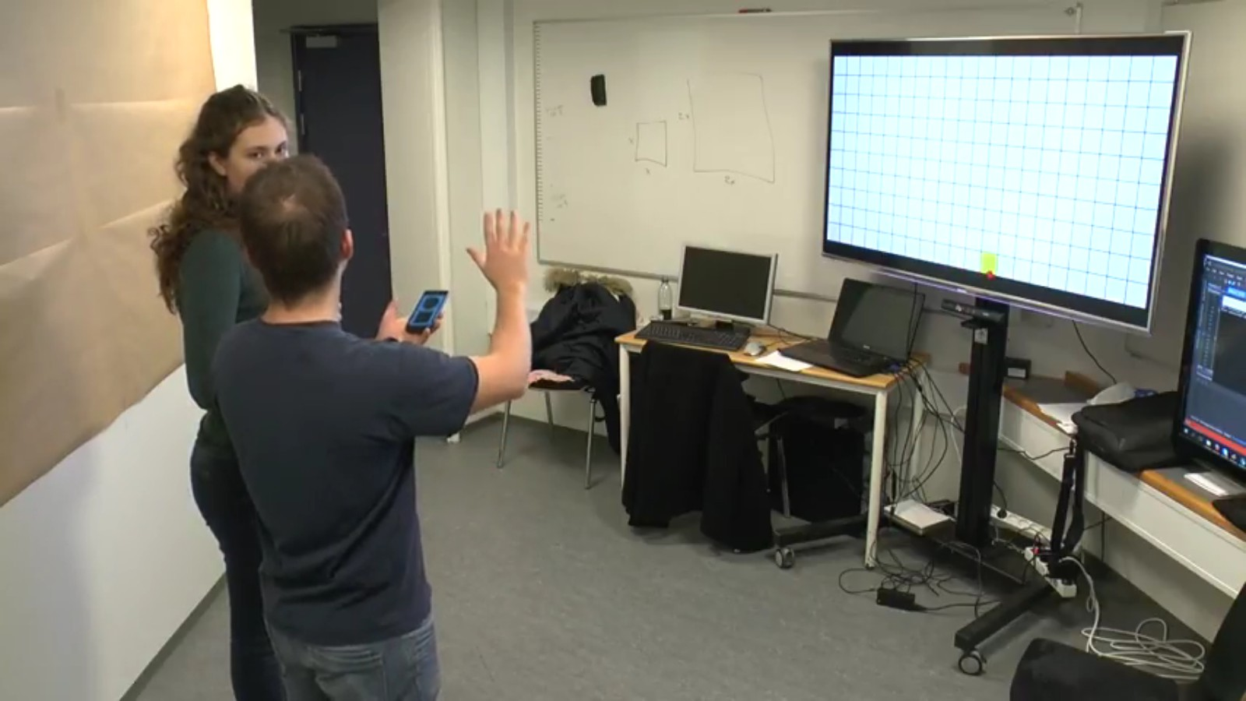

Pinch technique

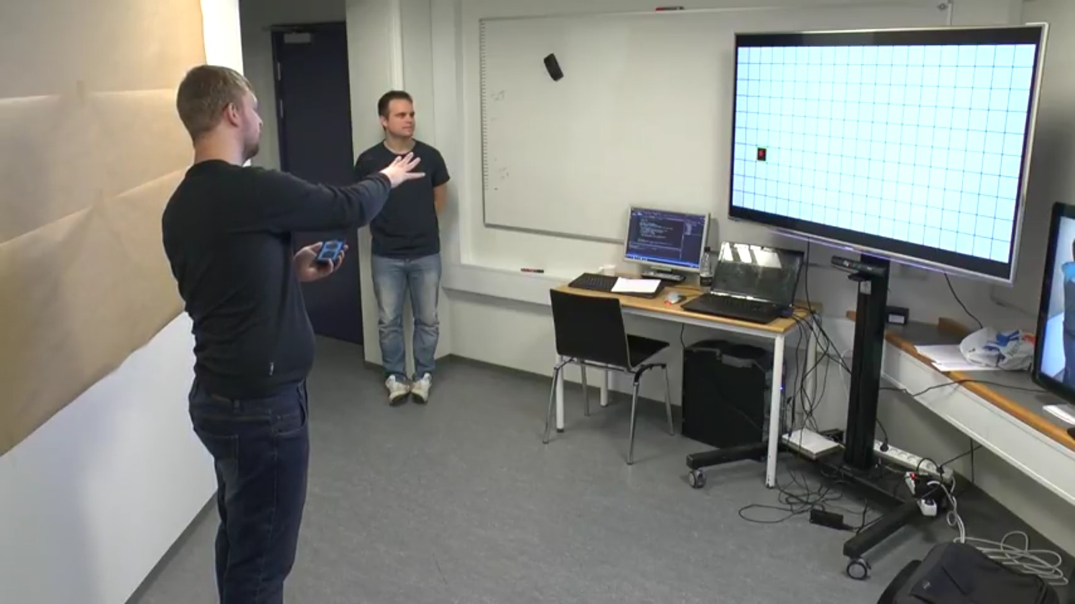

Pinch technique

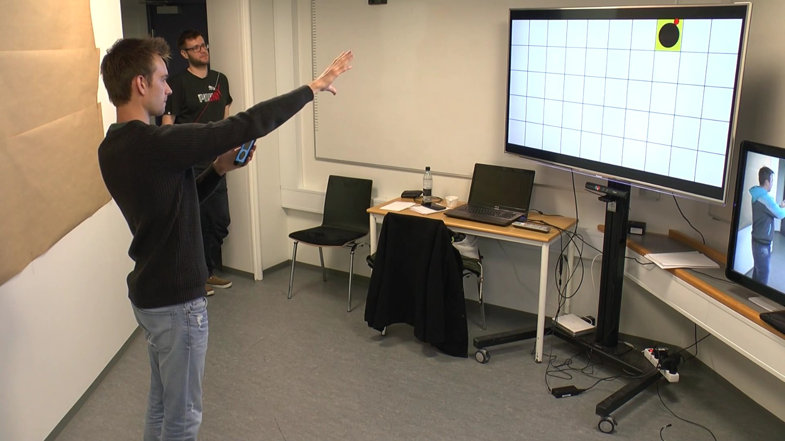

Swipe technique

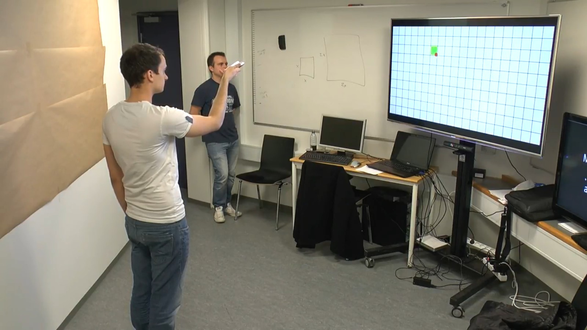

Throw technique

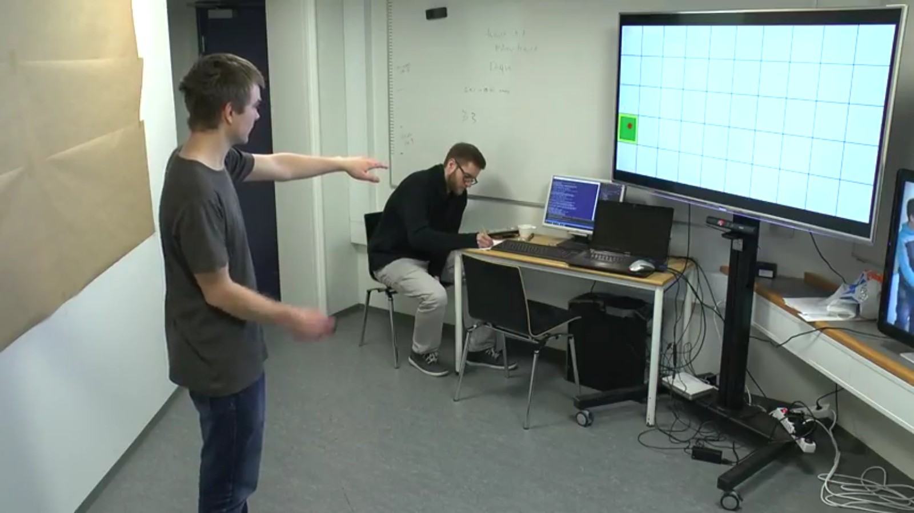

Throw technique

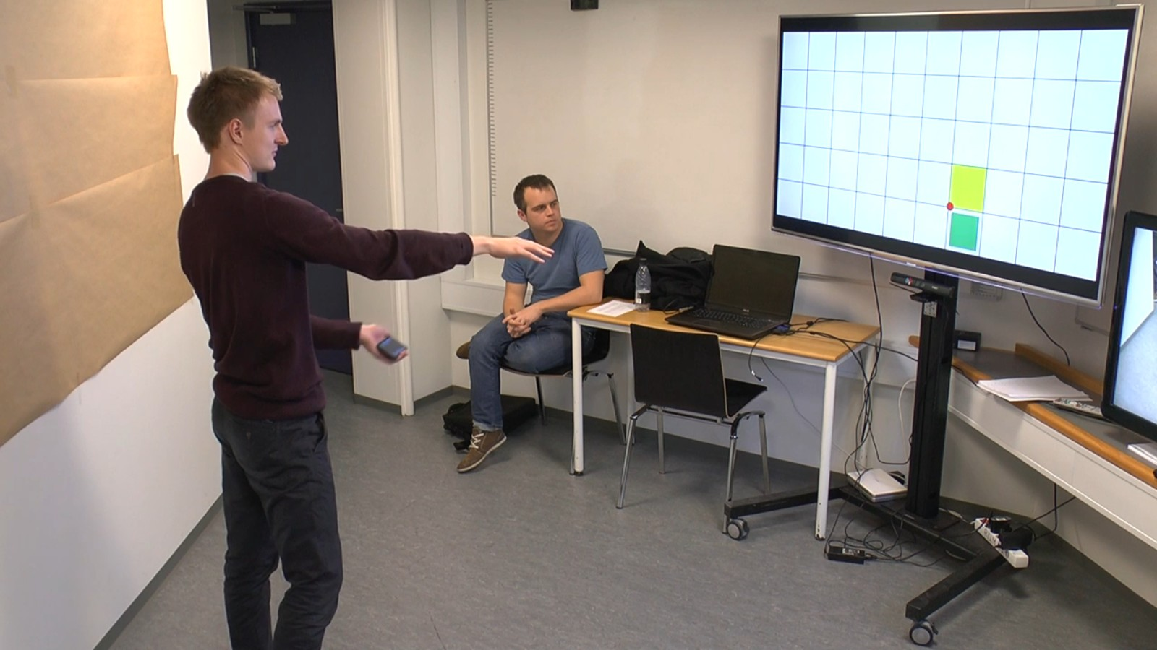

Tilt technique

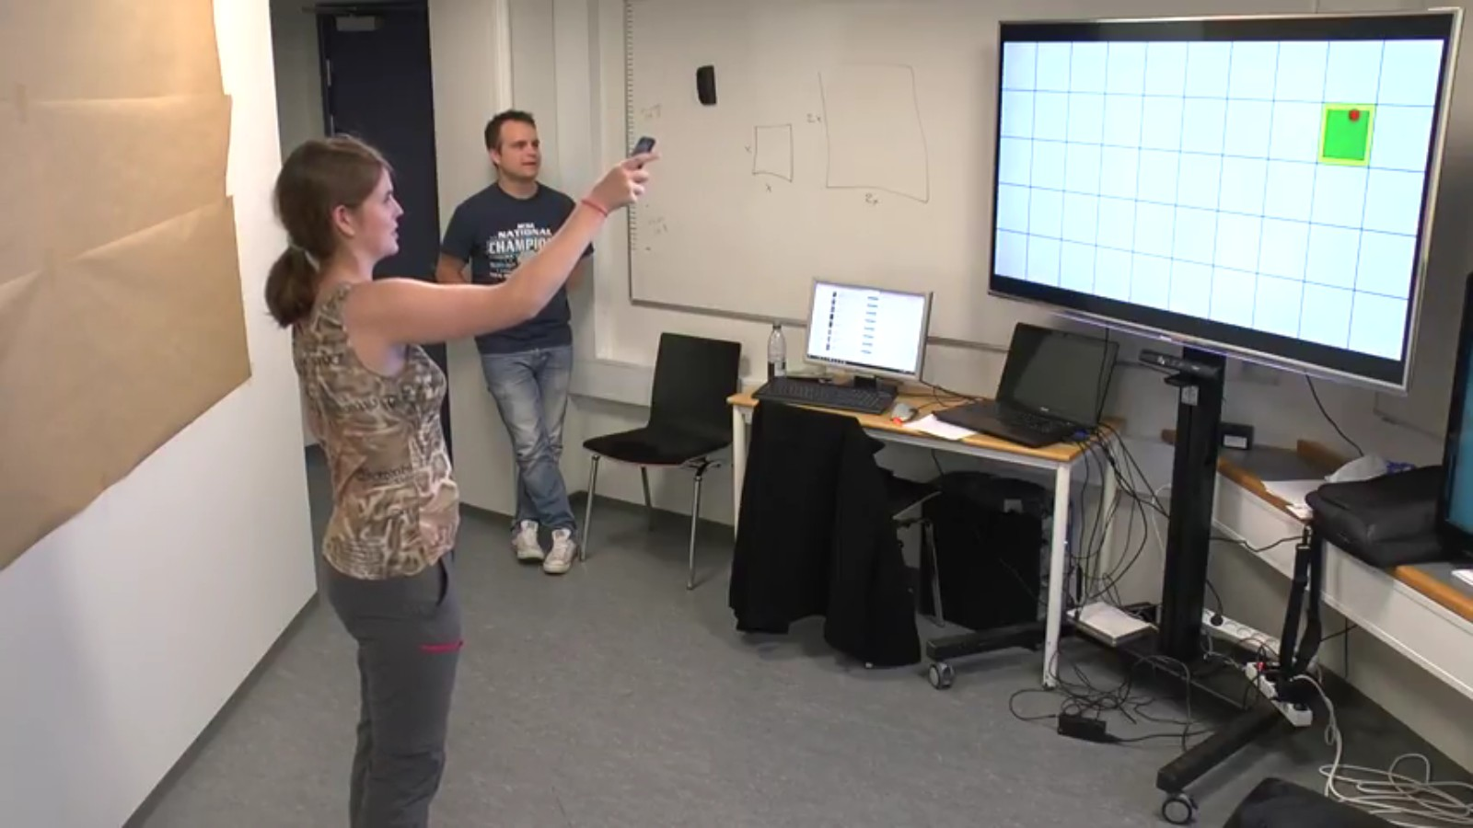

Participant on a chair

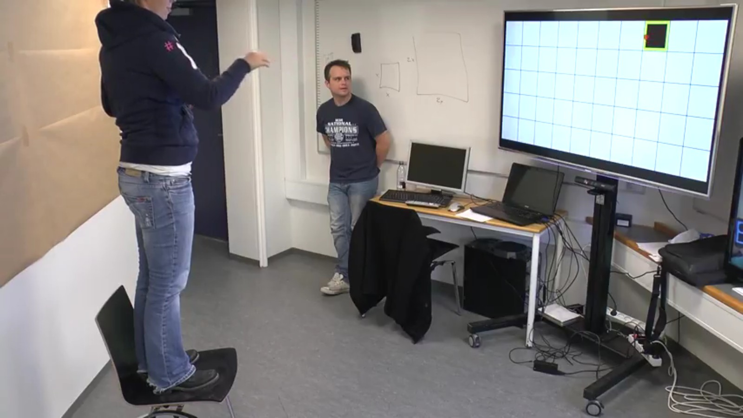

Pilot test

